May 19, 2017

Donald Rucker, MD
National Coordination for Health IT
Department of Health and Human Services
300 C Street SW
Washington, DC 20201

Dear Dr. Rucker,

The Health IT Policy Committee (HITPC) and Health IT Standards Committee (HITSC) gave the following charge to the Public Health Task Force (PHTF):

Overarching Charge:

The Public Health Task Force will make recommendations to help inform public health issues and challenges related to health IT.

Detailed Charge:

Make specific recommendations to better assist in the standardization of pregnancy status data, clinical decision support in health IT systems, and case management in public health settings—which are important components to addressing many public health challenges. Zika will be used as the use case for these recommendations.
- Capture Pregnancy Status: Identify the current challenges associated with the collection of pregnancy status when a Zika test is ordered. How could standardization help to resolve these challenges?
- Send and Share Pregnancy Status: Identify best practices for sharing pregnancy status from the provider to both commercial labs and public health entities.
- Use of Clinical Decision Support: Is there a need to automate the clinical decision support (CDS) process in order to identify risk and report timely information to public health? If so, what existing standards-based approaches for automating the CDS process are available as part of Zika response (i.e., Structure Data Capture (SDC), Clinical Quality Framework (CQF) be used?)
- The Electronic Initial Case Report (eICR) Identify mechanisms for how to move electronic case reporting forward.

Background:

The Public Health Task Force first convened on December 20, 2016. The membership comprised of representatives from public health, laboratories, and health IT developers. The PHTF sought to provide recommendations on the most impactful policy, technical, and public-private approaches that could be implemented to improve the standardization of pregnancy status data, clinical decision support in health IT systems for submission to public health, and case management in public health settings. The ability for public health agencies to receive pregnancy status data, especially during the Zika virus outbreak, is vital to ensure appropriate testing and follow-up care for patients, particularly exposed pregnant women and their infants. An overarching theme from PHTF members was to create recommendations that not only focused on the up and coming summer Zika season, but also was applicable to other reportable conditions (e.g., Hepatitis, Syphilis, and HIV) where pregnancy status is relevant. The PHTF members felt confident that recommendations on specific pregnancy status data elements along with possible transmission standards could be identified in the short timeframe of the charge. However, specific recommendations on clinical decision support and electronic case management would have to remain broad in scope due to the short timeframe and additional research needed.

To begin, the PHTF created principles to allow an open, honest and balanced discussion and reminded members to keep in scope of the charge. PHTF members participated in several initial presentations and discussions to provide background and context to the charge. An in-person hearing was held on February 8, 2017, which provided PHTF members with testimony from public, private and industry subject matter experts. These experts testified on four panels. Each panel focused on the charge from a unique perspective. Specifically, the panels focused on (1) public health departments, (2) labs & standards, (3) clinical decision support & electronic health records (EHRs), and (4) clinical workflow. Comments from this hearing helped to inform and shape the PHTF recommendations.

As a result of the hearing, and as noted in Appendix B, PHTF members sought additional information through deliberations and follow-up on:
- Case Reporting—Digital Bridge (an electronic case report pilot project funded by Robert Wood Johnson Foundation)
- U.S. Zika Pregnancy Registry
- Data elements for capturing pregnancy status
- Clinical decision support
- Electronic laboratory reporting (ELR) of pregnancy related data
- Patient-centric tools/resources (e.g., myhealthfinder)

Draft recommendations were presented to the HITPC and HITSC on March 8, 2017 for feedback. One area of particular interest of committee members was the process for how public health receives information today on reportable conditions. Specifically, the committee members discussed the objectives of public health when confronting new or emerging infectious disease threats that are reportable conditions. These objectives include: determining and tracking the burden and distribution of disease, identifying patients at risk, recommending measures to prevent cases, ensuring proper use and interpretation of laboratory diagnostic tests, identifying local transmission, and providing guidance to the medical community in managing cases.

Overview of Information Flow:

Following the March 8 meeting, the below diagram was created to provide an overview of the information flow process. The diagram recognizes that there are multiple modalities for information flow with a move towards more electronic, standards-based flow. While the diagram has single boxes for the entity types (individual, public health, healthcare provider and laboratory), each of these entities represents a diverse group. Discussions during the various meetings of the PHTF indicated that much of the complexity of moving information among these entities is a result of their large numbers, their different needs and capabilities and their differences in population, geography and law.

The below chart demonstrates a summary of the discussed information flow process.

- Guidance initiated from public health
- Healthcare providers provide guidance to individuals
- Individuals send health data to providers (work in progress)
- Test orders are transmitted from provider to labs
- Reports (results) are transmitted from labs to providers
- Reports (results) are transmitted from labs to public health (ELR)
- Electronic initial case report (eICR) to public health (work in progress)

Please note that the hatched arrows are, for the most part, not yet in production.

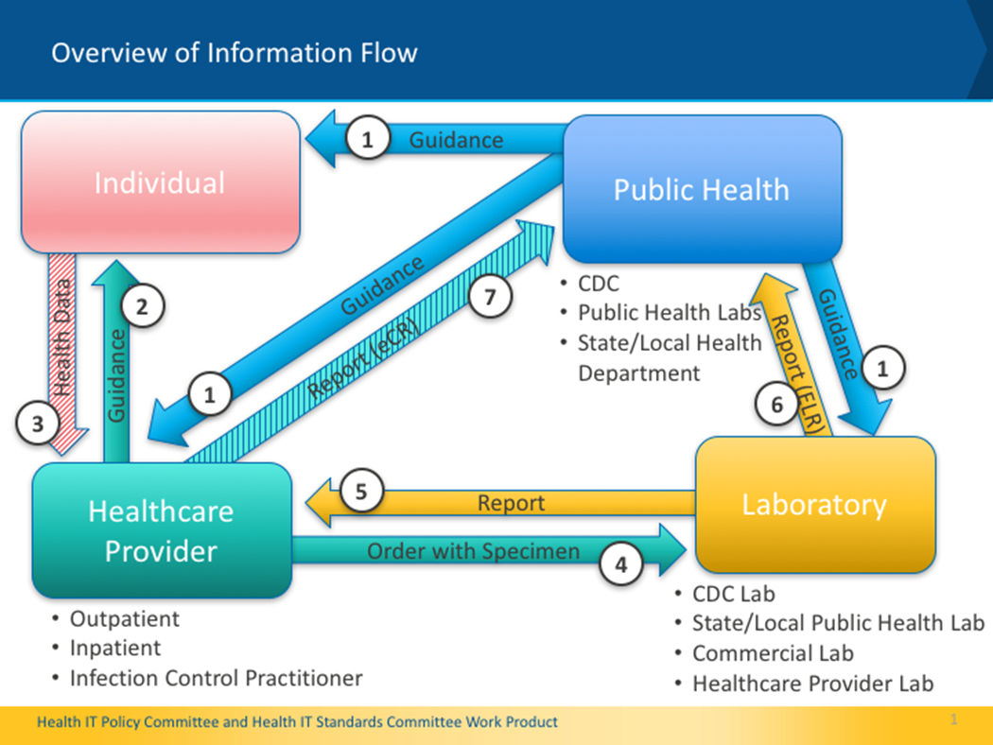
Figure 1: Overflow of Public Health Information

Additional Considerations:

During the March 8 meeting, HITPC and HITSC members also wanted to confirm that the final recommendations support:
- an all hazards approach,
- patient engagement,
- other data such as travel history,
- short and long-term solutions, and
- alignment with other clinical decision support and electronic case reporting efforts.

In addition, the PHTF members discussed at length the importance of linking maternal and infant records in a hospital EHR and displaying prenatal maternal health data in the infant’s record so that the pediatrician has easy access to it. It was determined that this was out of scope to include in the recommendations.

The PHTF members deliberated and sought additional background information to address the issues raised by the HITPC and HITSC members. As a part of the final recommendations, the PHTF members also wanted to recognize the legal constructs of public health agencies to protect the privacy of individuals while, simultaneously, needing to collect confidential patient information to protect the health and safety of all Americans. The PHTF reinforced in the recommendations that public health agencies can leverage their existing authority to require the transmission of pregnancy status as long as they adhere to state and local laws.

Challenges and Recommendations:

Based on the deliberations of the PHTF and the feedback of the Committee members, the PHTF presented the challenges in the current landscape and final recommendations designed to address these challenges. The HITSC and HITPC agreed to the recommendations on March 30, 2017, which are listed below and reflect the final deliberations of the Committees.

Charge 1: Capturing Pregnancy Status

- Challenges:
  - There is no standard to capture pregnancy status and associated data in an EHR
  - There is no existing consensus on the minimum public health data elements for pregnancy, our goal was to identify those priority elements

- Recommendations:
  - Disseminate the prioritized data elements identified by the Task Force related to pregnancy status
  - Promote “Ask on Order Entry” for transmission via ELR to capture pregnancy status for tests for reportable diseases where pregnancy status is relevant
  - Publish pregnancy data standards in ONC’s Interoperability Standards Advisory (ISA)
  - Explore ways for the patient (individual) to electronically self-report pregnancy status and other related data and electronically share that data with the provider’s EHR

Charge 2: Sending and Sharing Pregnancy Status

- Challenges:
- Public health does not consistently obtain pregnancy status electronically. For example:
- Electronic Laboratory Reporting (ELR) inconsistently provides pregnancy status information and, at times, only for certain diseases
- Electronic Case Reporting from EHRs is not currently in place
- Pregnancy status is needed not only for follow-up, but also is needed at the time a test is ordered for prioritization and to ensure pregnant women are being tested appropriately

- Recommendations:
- Promote that pregnancy status be transmitted for Zika and other reportable conditions (including chronic reportable conditions) where pregnancy status is relevant
- In the short term, expand the use of ELR to transmit pregnancy status to public health for Zika and other reportable conditions; while Ask on Order Entry is the preferred method to capture pregnancy status, promote the use of specific prenatal Zika test to indicate pregnancy status
- Publish the pregnancy data standards for transmission in the ONC Interoperability Standards Advisory
- Encourage state and local jurisdictions to leverage existing public health authority to require transmission of pregnancy status in accordance with state and local laws
- Promote the use of ONC's Interoperability Proving Ground (IPG) as a mechanism to share information on public health interoperability projects

Charge 3: Clinical Decision Support
- Challenges:
- Guidelines for identification of patients at risk for emerging infectious disease can be complex and often change
- State and local agencies may have variations on the guidelines
- Guidelines for choosing the appropriate laboratory tests are complex (e.g., as noted in the hearing, over 300 of the wrong Zika lab tests were ordered in Texas) leading to missed or erroneous diagnoses
- Guidelines for follow up and case management change during the course of an epidemic
- CDS implementation in the EHR happens at the provider level
- Recommendations:
  - Follow demonstration projects that have shown how CDS from public health can be incorporated into EHRs (e.g., RCKMS) to identify best practices for future recommendations
  - Explore sharing of CDS implementations across provider locations by promoting the use of Agency for Healthcare Research and Quality (AHRQ)’s CDS Connect, a web-based repository, as a mechanism to share information on public health interoperability projects related to CDS
  - In the short term, encourage the use of CDS to improve access to human readable guidance and to identify patients at risk
  - Explore mechanisms to enable consumers to identify and document their own risks including travel, pregnancy status and pregnancy intention and to share this data with their providers (e.g., myhealthfinder APIs)
  - Explore the use of open APIs for CDS (e.g., CDS Hooks to deliver CDS to EHRs)

Charge 4: The Electronic Initial Case Report (eICR)

- Challenges:
  - Public health does not currently collect electronic case reporting information from EHRs
  - Digital Bridge and other electronic case report (eCR) projects are in their infancy

- Recommendations:
  - Incorporate Charge 1 recommendations for collection and sharing of pregnancy status into the eICR
  - Leverage current work from existing eCR projects (e.g. Digital Bridge) to promote best practices and standards for reporting pregnancy status with the initial case report as well as follow up and case management
  - Explore the use of new or maturing standards such as Structured Data Capture and SMART on FHIR as methods for eCR
  - Promote the use of ONC's Interoperability Proving Ground (IPG) as a mechanism to share information on public health interoperability projects related to eCR

We appreciate the opportunity to provide these recommendations and look forward to discussing next steps.

Sincerely yours,

/s/ /s/

Paul S. Tang, MD Kathleen Blake, MD, MPH
Co- Chair, Health IT Policy Committee Co-Chair, Health IT Policy Committee

/s/ /s/

Lisa Gallagher Arien Malec
Co-Chair, Health IT Standards Committee Co-Chair, Health IT Standards Committee

Enclosures:
- Appendix A: Background on the Public Health Task Force
- Appendix B: Deliberations Related to Each Charge (1-4)
- Appendix C: Additional Background Information

Appendix A: Background on the Public Health Task Force

Member | Organization | Role
Larry Wolf | Strategic Health Network | Co-chair
Anne Fine | New York City Department of Health and Mental Hygiene | Co-chair
Andrew Wiesenthal | Deloitte Consulting, LLP | Member
Floyd Eisenberg | iParsimony, LLC | Member
J. Marc Overhage | Cerner Health Services | Member
Noam Arzt | HLN Consulting, LLC | Member
Susan Mcbride | Texas Tech University Health Sciences Center | Member
Richard Loomis | Practice Fusion | Member
Anjum Khurshid | Dell Medical School, University of Texas at Austin | Member
Janet Hamilton | Florida Department of Health | Member
Julia Gunn | Boston Public Health Commission | Member
Steve Hasley | American College of Obstetricians and Gynecologists | Member
Brian Anderson | athenahealth | Member
Riki Merrick | Association of Public Health Laboratories | Member
Chesley Richards | Centers for Disease Control and Prevention | Federal Ex Officio
Margaret Lampe | Centers for Disease Control and Prevention | Federal Ex Officio
James Daniel | ONC/HHS | ONC Lead
Figure 2: Public Health Task Force Membership

Task Force Principles:

- Clarity of purpose – Understand the charge and ensure that it is addressed. Use the clinical and public health guidelines and processes to inform technology recommendations.
- Bright spots - Learn from examples of success. Build on existing capabilities.
- Engage Stakeholders – Ensure input and interaction with a wide range of stakeholders.
- Parsimony – Recommend the minimum necessary and sufficient to accomplish the goals.
- Generality – Recommendations should support the specific issue being addressed, in this case Zika, and should more broadly be applicable to a range of issues, including related information needs and preparing for future emerging public health needs.
- Pragmatic – Recommendations should be actionable and efficient, especially in the use of clinician time and effort.
- Balance Priorities – Stakeholders have many competing priorities and regulatory requirements. As much as possible, we should align and coordinate our efforts with other requirements.
- National Scale – Address the complexities of a nation-wide implementation.

Appendix B: Deliberations Related to Each Charge (Charge 1)

Charge 1 - Capturing Pregnancy Status Background from Hearing

- Pregnancy status is critical for multiple infectious diseases of public health importance (e.g., Zika, Perinatal Hep B, Syphilis, HIV, Varicella, Listeria)
- Lab-diagnosed cases for investigation should be prioritized (especially necessary for higher volume diseases or diseases where timely intervention is needed)
- Testing of vulnerable pregnant women is critical to identify those at risk
- Follow-up on potentially exposed or infected infants is critical and must be done in a timely fashion since testing of the infant must be done in the first 48 hours of life
- Appropriate guidance to providers regarding test interpretation and case management is needed – in the case of Zika virus, laboratory testing and interpretation is extremely complex

Charge 1 - Capturing Pregnancy Status Pregnancy Priority Data Elements

- Developed key priority data element specifications for public health (i.e., standards for collecting this information)
  - Vetted recommendations concurrently through:
    - Health IT developers (i.e., EHRA and appropriate HL7 working groups)
    - Public health (i.e., CSTE, CDC)
    - Health care providers (e.g., OB/GYNs, Pediatricians, health care systems)
- Recommended that the list of pregnancy data elements should be included in ONC’s Interoperability Standards Advisory

Charge 1 - Capturing Pregnancy Status Data Elements Prioritized
* Identified as critical at hearing

Priority Data Elements (detailed spreadsheet)
- Pregnancy status* (yes, no, possible, unknown)
- Certainty status of pregnancy (i.e., ultrasound, lab test evidence)
- Date pregnancy status recorded*
- Estimated Delivery Date*
- EDD determination method
- Gestational Age (alternate to EDD)*
- Date Gestational Age determined (alternate to EDD)*
- Method of Gestational Age determination (alternate to EDD)
- LMP (alternate to EDD)
- Pregnancy Outcome*
- Pregnancy Outcome date*
- Postpartum status*

Charge 1 - Capturing Pregnancy Status Consumer Engagement Recommendation from Joint Committee

- Explored myhealthfinder
  - Created by the U.S. Department of Health and Human Services (https://healthfinder.gov/myhealthfinder/)
  - Tailors preventative services based on individual… age, sex, pregnancy status, etc.
    - Provides list of recommendations for the individual
    - Does not retain patient information
    - Uses API, can be rebranded myhealthfinder https://myhealthfinder.gov/FreeContent/ (i.e., CVS Health/Minute Clinic)
    - Explore ways for the patient (individual) to electronically self-report pregnancy status and other related data and electronically share that data with the provider’s EHR.

Appendix B: Deliberations Related to Each Charge (Charge 2)

Charge 2 - Sharing Pregnancy Status Background

Public Health Authority for Receipt of Pregnancy Data

- Public health has broad authority to collect data to prevent and control disease and protect public health (Whalen v. Roe (1977))
- State and Local Health and Sanitary Codes authorize receipt and investigation of reportable disease data by public health
  - Electronic Laboratory Reporting
  - Case reporting
  - Case and contact investigation and management (includes the collection of clinical and demographic data from the EHR or other sources)
  - Outbreaks and “Unusual Manifestations of Disease”
- HIPAA permits PHI disclosure to public health without patient consent
  - ONC’s fact sheet: Permitted Uses and Disclosures: Exchange for Public Health Activities
- Confidentiality is rigorously protected by public health laws at all times; Information use is limited to the purpose for which it was collected (308(d)of the Public Health Service Act)
- Information that could result in the identification of an individual is not released
- Pregnancy related information may be required to be submitted when relevant

Charge 2 - Sharing Pregnancy Status Review of Updates

- Recommended Short Term Approach
  - Promote Ask on Order Entry for Zika and other reportable conditions for which pregnancy status or other key data points are relevant or required by public health
    - ELR enables Ask on Order Entry data elements to flow to public health through existing infrastructure (not currently in place for many labs or health departments)
    - ONC’s 2015 Edition supports Ask on Order Entry
    - Public health labs require additional infrastructure to support Ask on Order Entry
    - Commercial labs require resources to reconfigure systems to support Ask on Order Entry
    - Public health departments will need to prepare to be able to accept ELR data collected in this manner via HL7
  - Promote the use of specific prenatal test name to indicate pregnancy status while Ask on Order Entry infrastructure is developed
- Recommended Long Term Approach
  - Promote the Electronic Case Report to enable public health to receive pregnancy status

Appendix B: Deliberations Related to Each Charge (Charge 3)

Charge 3 - Clinical Decision Support (CDS)

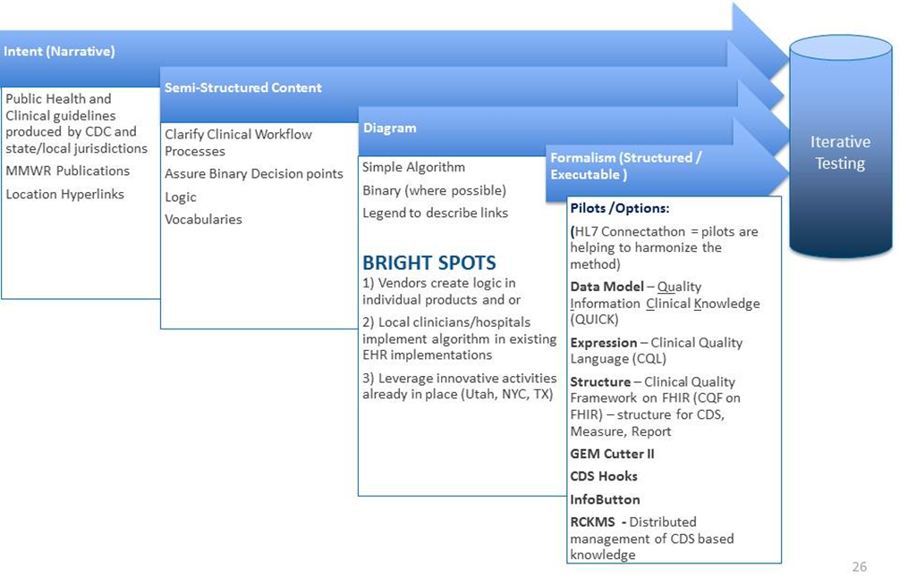
Figure 3: Clinical Decision Support (CDS) Diagram

Charge 3 – CDS Comments from Public Hearing

- CDS for public health and emerging risks should:
  - Identify at risk individuals
  - Ensure appropriate tests are ordered: for example, trigger points for particular actions (tests ordered for infant at time of delivery)
  - Provide clinical management and patient education
  - Provide guidelines for when to report to public health
  - Provide stable URLs that can be embedded in an EHR which allows access to updated guidance from CDC and other public health sites (currently “pull”)
  - Provide guidance that is specific to the location of the health care facility – guidance and other information required by medical providers often varies across jurisdictions for legitimate reasons (e.g., how to report, where to call for further guidance, etc.)
- CDS 5 Rights
  - Right channel/Right Information/Right intervention format/Right person/Right time = Where/What /How/Whom/When (Osheroff, 2012)

Charge 3 – CDS Review of Updates from Additional Stakeholders

- Discussion with CDS Hook Experts
  - CDS Hooks is an open source project and is a model for describing how an EHR can use a remote decision support service. CDS Hooks uses FHIR and SMART.
    - Prototype implementations—4 EHR vendors and 30 CDS organizations and anticipated production by 2017
  - Argonaut Project has chosen CDS as a focus for 2017
- Recommendations for CDS charge
  - Explore the use of open APIs for CDS, such as CDS Hooks
  - Explore use of CDS for consumers to self-identify risks, opportunities for prevention, and recommended actions

Appendix B: Deliberations Related to Each Charge (Charge 4)

Charge 4 – eICR Clarification—Definitions

- Define the difference between the eICR and eCR*

  - eCR (electronic case reporting)—the fully or semi-automated generation and electronic transmission of reports of potential cases of reportable diseases and conditions from an electronic health record (EHR) or health information technology (IT) system to appropriate public health authorities, replacing the historically paper-based process.

  - eICR (the electronic initial case report)—The electronic initial case report (eICR) is a first step in implementation of eCR. The eICR will convey a standard set of data elements, vocabularies and value sets to Public Health Agencies (PHAs) for all reportable conditions in all jurisdictions. It is termed, initial as the report may be the first report made to public health from the clinical provider, containing just enough pertinent data for PHAs to initiate investigation or other appropriate public health activities as necessary.

*As defined by Council of State and Territorial Epidemiologists (CSTE) and Mac Kenzie, W.R., Davidson, A.J., Wiesenthal, A., et al. (2016). The Promise of Electronic Case Reporting. Public Health Reports, 131 (6), 742-746. Retrieved from http://journals.sagepub.com/doi/full/10.1177/0033354916670871

Charge 4 – eICR Background from Hearing - Value of the eICR

- More complete, critical and accurate clinical and demographic data beyond ELR in real time for action
- Directly links health care to population health
- Early detection of cases and the detection of pregnancy in existing cases allows earlier intervention and diminished transmission of disease
- Improves detection of outbreaks
- Responds directly to local and state partner needs
- Diminishes burden on healthcare provider to report

Appendix C: Additional Background Information

Algorithms for developers (Information)

Zika Problem List | Hyperlink to Zika Public Health Information
1. Areas with active Zika transmission | Areas of known Zika virus transmission.  http://www.cdc.gov/zika/geo/index.html
2. Travel and Mosquito Prevention Advice | a. Advice for patients about how to avoid Mosquito bites.  http://www.cdc.gov/zika/prevention/index.html
b. Advice for patients about which mosquito repellents are effective and safe to use in pregnancy. [DEET, IF3535 and Picardin are safe during]
https://www.epa.gov/insect-repellents/find-insect-repellent-right-you
3. Prevention of Sexual Transmission | The most current interim guidelines for prevention of sexual transmission of Zika virus.  http://www.cdc.gov/zika/transmission/index.html  http://www.cdc.gov/mmwr/volumes/65/wr/mm6512e3.htm
4. Signs and Symptoms | Signs and Symptoms of Zika virus disease and information about how a clinician might differentiate Zika virus infection from other similar infections.  http://www.cdc.gov/zika/symptoms/index.html
5. Possible microcephaly association | Known information about association between Zika virus infection and microcephaly and other known complications.  http://www.cdc.gov/ncbddd/birthdefects/microcephaly.html
6. Zika Virus Diagnostic Testing | Explanation of diagnostic tests for Zika virus and which to use based on the patient’s clinical and exposure history.  http://www.cdc.gov/zika/hc-providers/diagnostic.html
Figure 4: Zika Problem List and Public Health Information

Algorithms for developers (Value Sets)

- Public Health Information Network Vocabulary Access Distribution System (PHIN-VADS)
  - https://phinvads.cdc.gov/vads/SearchVocab.action
  - PHIN VADS Hot Topics
- Zika virus disease associated Lab Vocabulary (ELR) - Includes value sets associated with lab testing algorithm for Zika, Chikungunya and Dengue
  - FILE: Zika_Lab_Test_Information_20160517.pdf - Testing algorithm information for Epidemiologist and Lab experts using standard vocabulary
  - FILE: Zika_virus_codes_for_ELR_20160517.xlsx - Technical information for ELR IT staff - LOINC and SNOMED codes
  - LINK: Information for State Public Health labs from CDC
- Zika vocabulary for EHR and Health IT vendors - Includes value sets for implementing the CDC's interim guidelines which could be used by EHR community for decision support or pick list.
  - LINK: Zika affected areas
  - FILE: Zika Virus Vocabulary for EHR - 02_01_2016.pdf - Includes value sets associated with Zika, Dengue, Chikungunya, Arboviral diseases, Pregnancy, Newborn and Infant.
  - FILE: Zika related CPT procedure codes_04152016.pdf - CPT procedure codes associated with Zika lab tests and imaging.

Vocabulary Sets

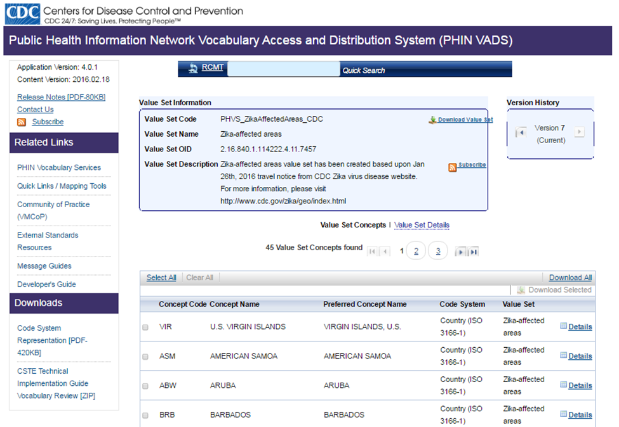
Figure 5: CDC, Public Health Information Network Vocabulary Access and Distribution System (PHIN VADS)

Innovative Clinical Decision Support Work for Zika

- ELR is currently being used to transmit pregnancy status for perinatal Hep B
- Morbidity and Mortality Weekly Report (MMWR): https://www.cdc.gov/mmwr/zika_reports.html
- Guideline Elements Model: http://gem.med.yale.edu/default.htm
- CDS Hooks: http://cds-hooks.org/
- Clinical Quality Framework - ONC Tech Lab: https://www.healthit.gov/techlab/testing_and_utilities.html
- Reportable Condition Knowledge Management System (RCKMS): http://www.cste.org/group/RCKMS

Bright Spots – Demos

- Digital Bridge
- Utah: Automated Surveillance
- NYC: Structured Data Capture (Federal Health Architecture demo)
- Health Alert Network (HAN) - CDC's Health Alert Network (HAN) is CDC's primary method of sharing cleared information about urgent public health incidents with public information officers; federal, state, territorial, and local public health practitioners; clinicians; and public health laboratories.
- Clinical Outreach and Communication Activity (COCA)—COCA, via CDC, prepares clinicians to respond to emerging health threats and public health emergencies by communicating relevant, timely information related to disease outbreaks, disasters, terrorism events, and other health alerts.
- Display of prenatal maternal information in the newborn infant’s record

Sample Potential Solution

Improving Outcomes with Clinical Decision Support: An Implementer’s Guide
By Jerome A. Osheroff, MD, FACP, FACMI

This is an example of a tool we can leverage as a framework for public health. It provides expanded and updated guidance on using CDS interventions to improve care delivery and outcomes in diverse care settings.

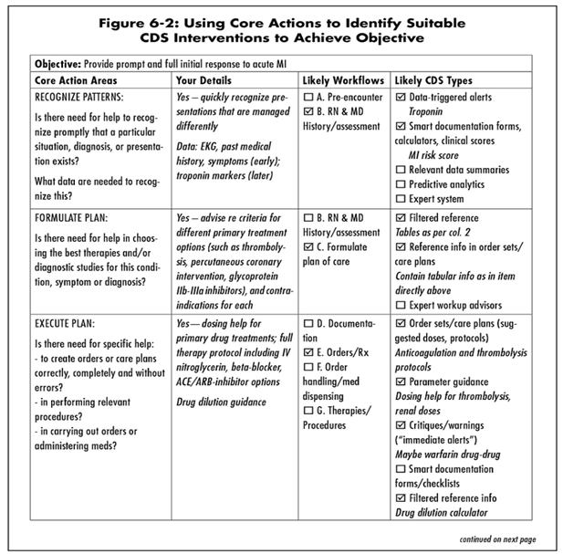
Figure 6: Excerpt from “Improving Outcomes with Clinical Decision Support: An Implementer’s Guide”. Using Core Actions to Identify suitable CDS Objectives to Achieve Object

Potential Solution for Public Health Labs/Ask on Order Entry

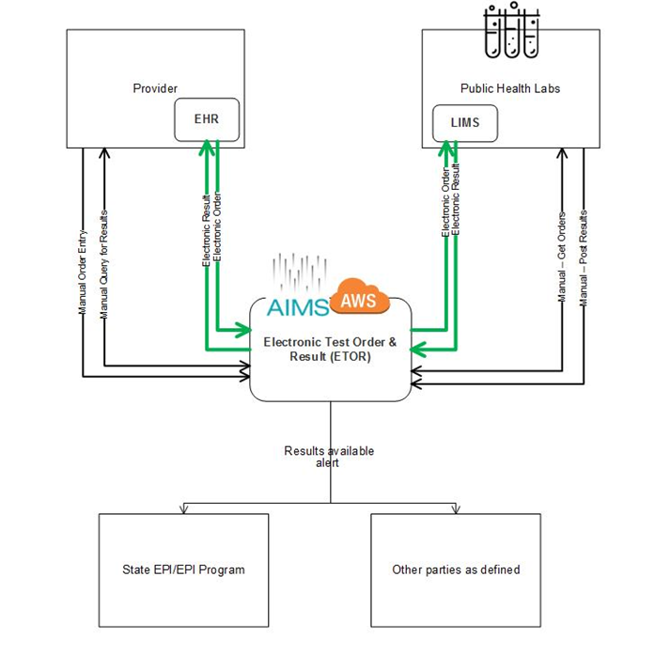
Figure 7: Potential Solution for Public Health Labs/Ask on Order Entry

eCR Digital Bridge High Level Architecture

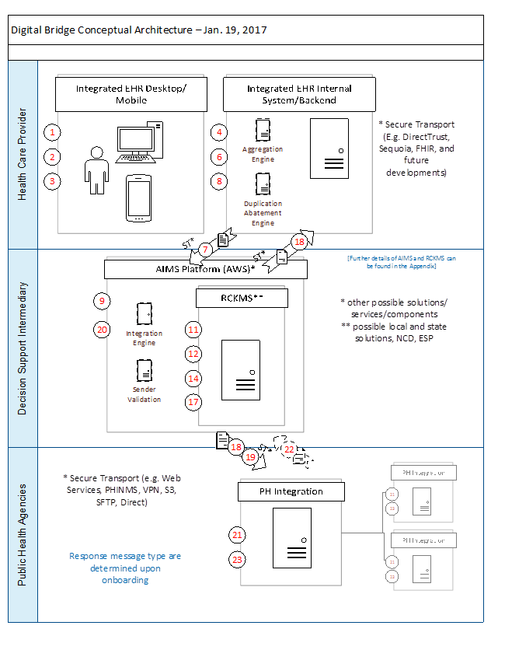
Figure 8: eCR Digital Bridge High Level Architecture

