Comments on USCDI – Device related Data Classes and Elements
Submitted by: FDA/CDRH
Level 2 Comments
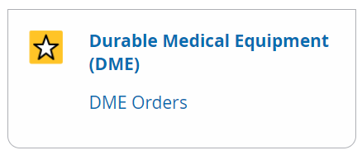
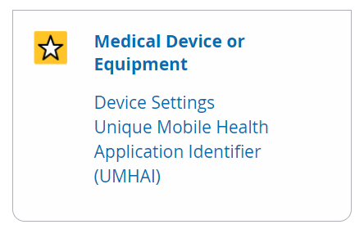
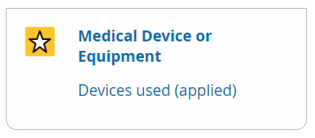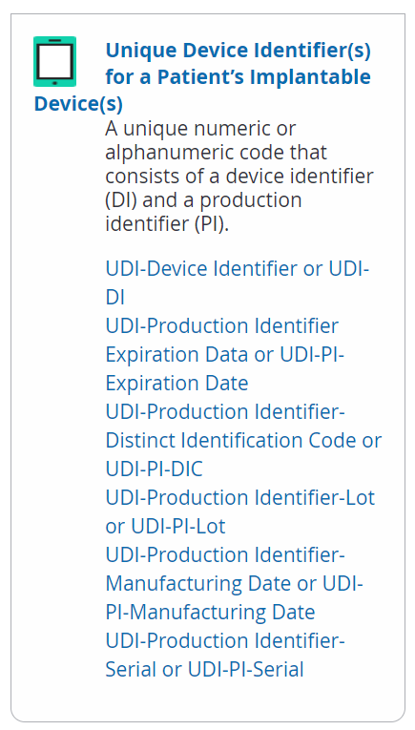

Currently USCDI has a data class for Unique Device Identifier(s) for a patient’s implantable device(s) and a proposed new data class for Medical Device or Equipment (under Level 2 and Comments) and Durable Medical Equipment (DME) (under comments). In order to correctly represent the data classes and the elements, the following changes should be considered for future versions of USCDI (also see Figure 1):
- The structure of the device information should be contained within one data class for “Medical Device or Durable Medical Equipment”
- The Medical Device or Durable Medical Equipment data class expands the scope of the existing unique device identification beyond implantable medical devices, the existing “Unique Device Identifier(s) for a Patient’s Implantable Device(s) class should be renamed given that the data elements proposed (and future data elements needed) intend to uniquely identify a medical device or durable medical equipment (i.e., Unique Device Identification). Unique Device Identifiers (UDI Carrier) are preferred for all device identification if they are present. When a UDI Carrier is not present (e.g., reporting historical use or implant of a medical device), other data elements may be used in combination to ensure correct identification.
- As the other proposed device-related information includes additional usage details about a device – e.g., device settings, procedure details, orders, application/software information, and device measurements or observations – those device data elements should be contained within the relevant USCDI data classes (e.g., procedures details) or within the proposed new device data class.
Figure 1: Proposed/Draft Reorganization of Data Classes and Data Elements
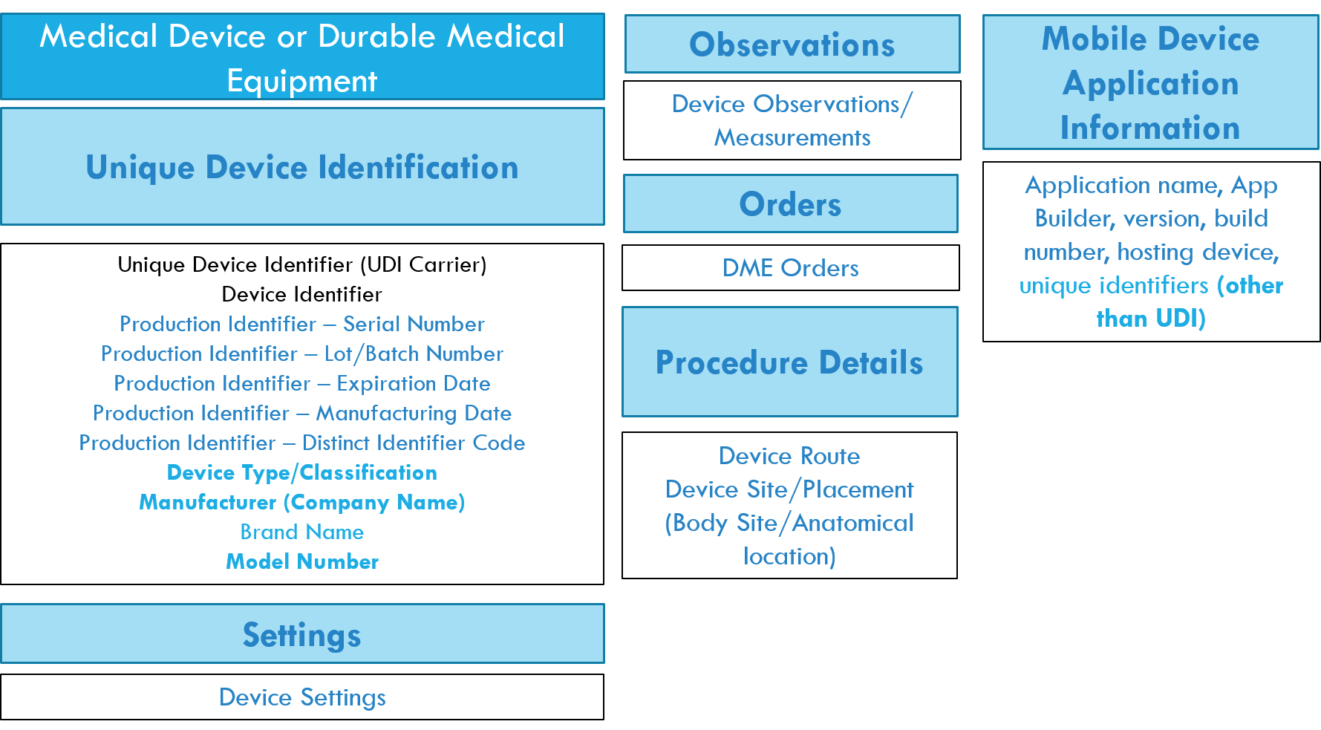
The FDA would like to work with the healthcare, research and regulatory informatics and data standards community to ensure that the device-related concepts are validated and correctly modeled within USCDI. We agree with the current maturity of the device-related concepts. We would like to work with ONC to further advance the maturity of the proposed device-related data classes and data elements currently specified in the Level 2 and in the Comments sections. We have noted several additional data elements that will aid in unique device identification when the UDI Carrier is not present (e.g., manufacturer, type, brand name and model number). The FDA will submit any new data elements for consideration via the ONDEC system.

