Frequently Asked Questions about Blue Button
What Is Blue Button?
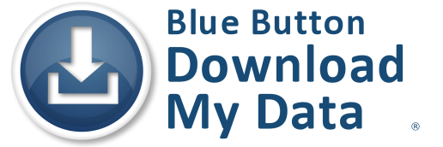
Blue Button is a symbol for consumer access to electronic health data. It represents giving patients easy, secure
electronic access to their personal health information - such as current medications, drug allergies, lab results, and claims and treatment data - in a downloadable and structured format they can use.
Your practice may already provide the capabilities for patients to view/download/transmit their personal health information electronically without calling it Blue Button or using the Blue Button logo.
Why Should My Practice Use Blue Button?
Using Blue Button can help support patients to be more engaged in their care and to be better informed facilitate coordination of care enhance the quality of care increase patient satisfaction with care. Using Blue Button can also help fulfill the Meaningful Use Stage 2 objective that requires more than 5% of all patients seen during the reporting period to view/ download/transmit their health information to a third party. The 2014 Stage 1 requirements also call for giving patients electronic access to their personal health record (PHR).
How can I learn more?
For help getting started using Blue Button:
- Contact your Regional Extension Center (REC)
- Contact your vendor to ask about their plans to provide patient access for downloading their PHR
- Read the guidelines for using the Blue Button logo
- Learn more about Blue Button and MU requirements

Benefits to Patients
When patients have access to their health information, they can…
- Print, download, or share it
- Export the information into apps or tools to better manage their health
- Exchange information securely with other providers
- Review the information for accuracy
What Should I Tell My Patients?
If your practice already uses Blue Button or has view/download/transmit capabilities:
- Encourage the patient’s interest in accessing their health information and confirm it is their right
- Explain how to use Blue Button (or other view/download/transmit capabilities)
- Make sure patients know who to contact on your staff for help if they have problems with viewing, downloading, or transmitting information
If your practice does not yet use Blue Button or have view/download/transmit capabilities:
- Encourage the patient’s interest in accessing their health information and confirm it is their right
- Tell patients what your practice does now to give them access to their health information, such as providing a clinical summary
- Let patients know about plans for launching a portal and using Blue Button; collect patient email addresses to prepare for a portal launch
Other Helpful Resources
- Learn more about Blue Button
- Tips on getting started for providers who offer a PHR or patient portal
- Take the ONC Blue Button Pledge

