Meaningful Use Stage 2
NIST EHR Randomizer Tool
Provider User Guide
Table of Contents
Purpose of the EHR Randomizer: 3
Before You Use the Randomizer: 3
Steps to Register and Perform the Test: 4
Glossary of Important Terms & Resource Links: 8
Document History 10

Purpose of the EHR Randomizer:
As part of the third measure for the Meaningful Use Stage 2 Transitions of Care Objective, Eligible Providers and Eligible Hospitals are required to document that they have sent a summary of care record to a different EHR than the one they are using for meaningful use.
If you do not electronically exchange a summary of care record with a provider who uses an EHR from a developer/vendor other than yours through your normal course of business, you should use the EHR Randomizer to conduct a cross-vendor exchange test with a CMS designated test EHR. There are some important things to consider when using the EHR Randomizer.
- The current test ONLY tests Direct and no other mode of exchange
- Providers can use the tool only if their vendors are able to work with the limited number of designated Test EHRs that are available to conduct the test
- It is only required if you don’t send at least one CCDA to a provider with a different EHR

Before You Use the Randomizer:
Before starting this test process you should be familiar with the following:
- Have a 2014 Certified EHR installed and in use in your practice, clinic or hospital
- Know your Direct Address and how to send a Direct message
- Be able to create a Summary of Care record (CCDA) and send it to another provider using Direct
- Determined that you need to use this tool because you are only exchanging information with clinicians using the same EHR as yours
- Talked to your vendor and obtained their support to conduct the test
Prior to registering on the EHR Randomizer application, you need to contact your EHR vendors and obtain the following key pieces of information. This information is vital to a successful test, and the Test EHR requires this information before starting the testing process. You should contact your EHR vendor or Health Information Service Provider (HISP), to get this information if you do not already have it at your fingertips before you register on the randomizer.
- Your Direct address – see below for a more in-depth description
- Information about whether your EHR vendor/HISP is Direct Trust accredited
  - If your EHR vendor/HISP is Direct Trust accredited, make sure you check with your vendor that they are able to exchange with one of the designated Test EHRs available on the NIST EHR Randomizer
  - If your EHR vendor/HISP is not Direct Trust accredited, you will need to get your trust anchor from them. A Trust Anchor is a technical document that you have to share with the test EHR before your systems are able to exchange information. Your HISP or EHR vendor can email it to you and you in turn can email it to the appropriate contact at the test EHR.
- A CCDA care summary with test/fake patient data generated from your EHR Do not use actual patient data for this test. Contact your EHR vendor if you are uncertain how to create a test patient in your system.
- Determine what processes or procedures your EHR vendor has in place to assist their customers with performing this test. It may be necessary for your EHR vendor to interact with the Test EHR you are matched with to troubleshoot technical issues.

Steps to Register and Perform the Test:
- Providers must first register on EHR Randomizer Website
- Complete the “My CEHRTs” tab on the Randomizer: enter the following information about your Certified EHR Technology (CEHRT):
Field Name | Explanation | Example
CEHRT Label | EHR Product Name or any label you want to give your product. This is helpful if you need to distinguish between multiple products (e.g. ER-EHR, Clinical EHR). | Professional EHR
Direct Address | Direct is an email protocol that allows a Doctor to send encrypted health information directly to known, trusted recipients over the Internet. It is very similar to the regular email you use today, but its contents are encrypted for security. The Direct email address looks much like a regular email address. This address can be used to send and receive encrypted patient data to and from other doctors or hospitals. If you do not know your Direct email address, you should contact the vendor who installed your system, they will know how to set this up for you. | test@direct.practiceA.org
Time Zone | Time zone of your location | America/Denver
Developer | Name of the vendor or company that developed your EHR. This list is updated with the certified products list known as the CHPL. The vendors listed may not be in complete alphabetical order, so check the entire list for your EHR vendor. | MyCompanyEHR
Direct Trust Accredited | Providers are not members of Direct Trust. Your EHR vendor or your Health Information Service Provider (HISP) may be accredited by Direct Trust. Contact your EHR vendor or HISP to find out if they are accredited by Direct Trust. Accreditation in Direct Trust determines the steps you’ll have to take to set-up the exchange with your system and the test EHR. If your EHR and the test EHR are both members of Direct Trust, you will not have exchange Trust Anchors to perform the exchange. Click here for more information about Direct Trust Accreditation. | No
Click Save
- Complete and review the “My Matches” tab: Once you’ve successfully entered all the information about your Certified EHR (the My CEHRTs Tab) you are ready to be matched to a Test EHR.
  - Click the button – Request a Match
  - Select your CEHRT from the list; these will be identified by the label you entered above.
  - If you are successfully matched with a test EHR it will display below the Request a Match button.
  - If you are not successfully matched, it may be due to lack of availability of the “Test EHR” in a given time period. You can check the entire list of “Test EHR” by clicking on the “Vendor CEHRT” tab, on the EHR Randomizer tool, to determine when a “Test EHR” will be available, to schedule a test.
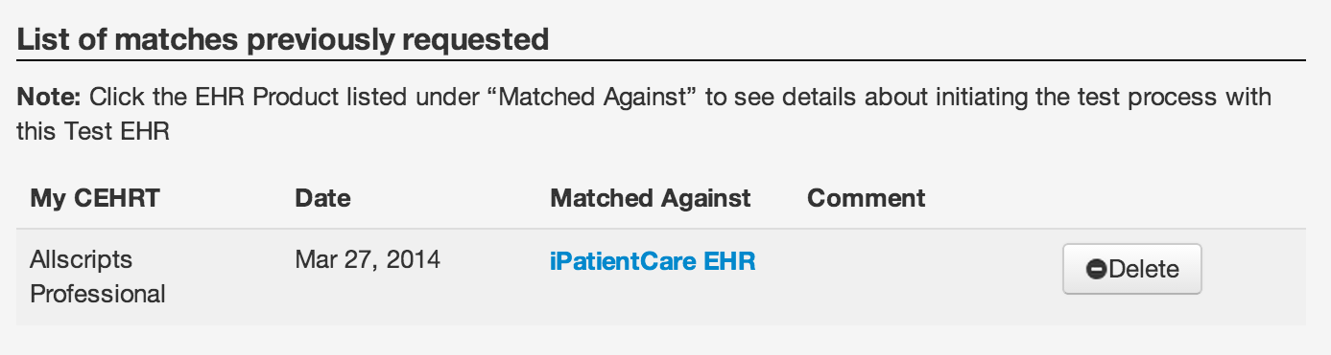
  - Click the Blue link under the heading “Matched against.” This will display key pieces of information about the test EHR that you will need in order to perform your test exchange. A screen shot of the details is included on the following page. Red circles identify the key pieces of information you will use to exchange with the test EHR.
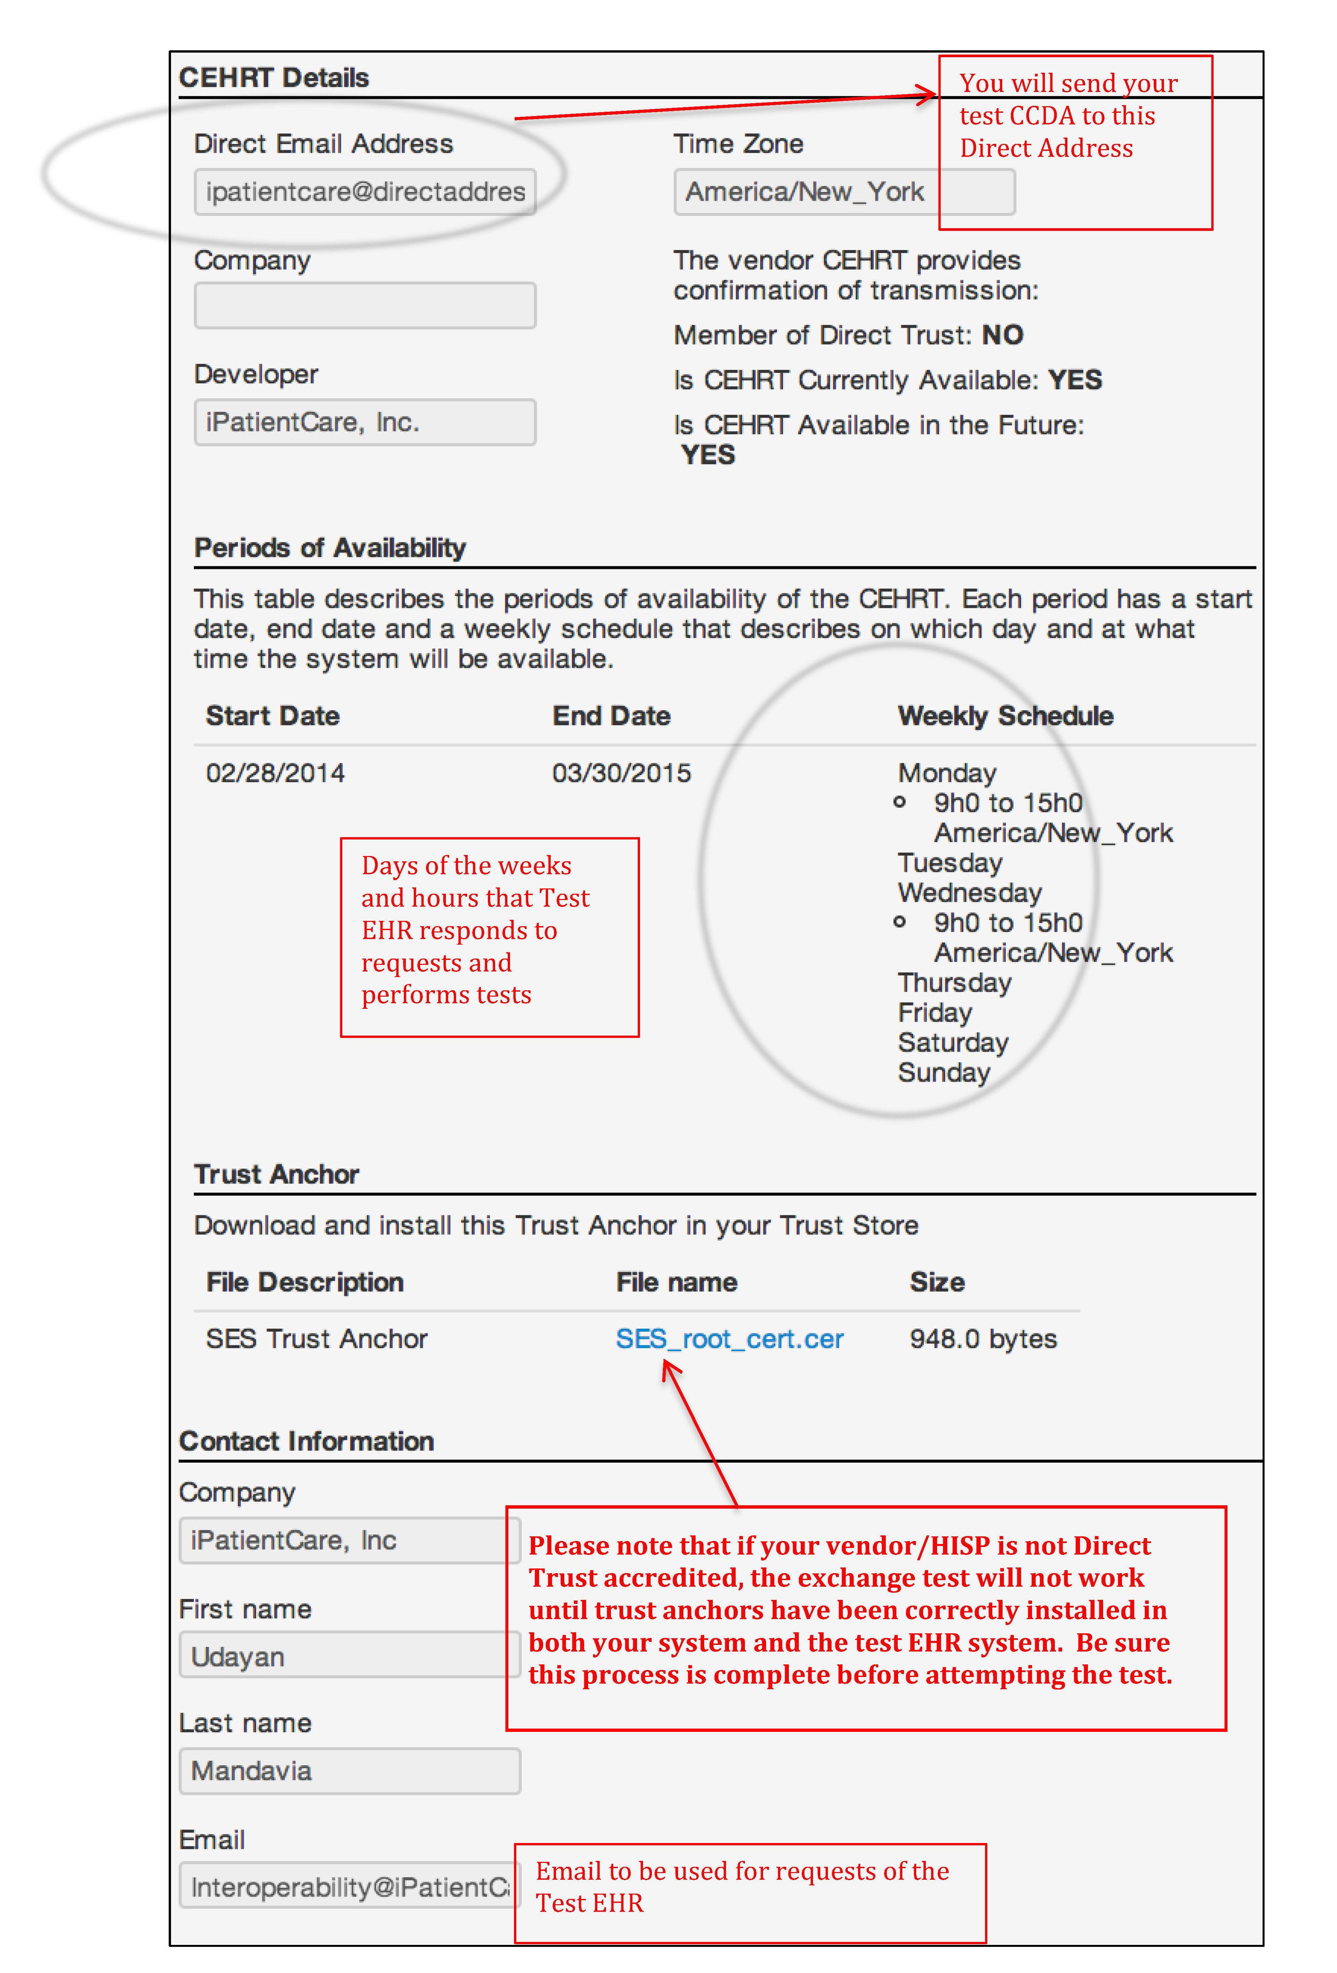
- Prepare for the cross-vendor exchange test:
To exchange with the Test EHR that you are matched with, you will have to engage your EHR vendor/HISP to assist with this process.
  - Using the email address provided by the randomizer (noted in the last box in the screen sheet above) contact the test EHR representative to schedule your test. Be certain to inform the Test EHR of your proposed reporting period for 2014. You need to allow at least 4 weeks to ensure a successful test. Be prepared to have the following information available for the Test EHR:
Contact name
Email address
Phone number
Location
Vendor information: System & Version (it must be 2014 certified)
Vendor contact (depends on response to troubleshooting question above)
Direct Address
Trust anchor (if necessary)
  - If your EHR vendor/HISP is not Direct Trust accredited:
    - Email the test EHR contact to arrange a method for sending your vendor’s trust anchor to the test EHR (if you followed these instructions, you received this from your vendor/HISP prior to starting the process).
    - Email your vendor/HISP and arrange for them to load the test EHR’s trust anchor, which is provided at the bottom of the “CEHRT Details” page on the Randomizer.
  - If your EHR vendor/HISP is Direct Trust accredited, proceed to step 5.
- Starting the Testing Process:
Once you’ve scheduled your test with the test EHR and trust anchors have been installed in both systems (yours and the test EHR’s), you are ready to start the testing process.
  - Create a CCDA care summary with data from a test patient in your EHR. Do not use real patient data.
  - Send the test CCDA to the Direct address of the test EHR (this is listed in the upper left hand corner of the Randomizer “CEHRT Details” page).
- Complete the test:
- You should receive an email message to your personal email you entered during the registration process from test EHR within 24 hours indicating that the test was successful. Once you receive confirmation that the CCDA was received, you have successfully completed your test!
- Save the email message indicating success in your records, as it is proof that you have met the requirements for Meaningful Use Transition of Care measure #3.
- If you do not receive an email message from the test EHR indicating success, email the test EHR contact to work on figuring out what went wrong. You may have to engage your own vendor/HISP to help troubleshoot. You will have to repeat this process until you receive a message from the test EHR indicating success.
- Once the test is successful, you have the ability to send care summaries to this test EHR in the future if you need to meet the requirement of measure 3 again.

Glossary of Important Terms & Resource Links:
Term | Definition | Resource Links
Direct Project | The Direct Project specifies a simple, secure, scalable, standards-based way for participants to send authenticated, encrypted health information directly to known, trusted recipients over the Internet. It focuses on the technical standards and services necessary to securely push content from a sender to a receiver and not the actual content exchanged. | Direct Project Overview  HealthIT.gov Resources
Direct Address | The email address that is specifically used to transport “Direct” messages. The messages can contain patient-specific and non-patient specific data, but are encrypted and secure to comply with HIPAA. Direct is a required protocol for sending and receiving Summary of Care records (CCDA) for Stage 2 meaningful use. You receive a Direct address from your EHR vendor or a Health Information Service Provider (HISP). | Direct Project Overview  HealthIT.gov Resources
HISP | The term Health Information Service Provider if HISP is used as both a function and an organizational model of how the Direct Project needs to be implemented and managed. Your EHR vendor can act as their own HISP, or partner with a HISP that manages all the activities associated with Direct. | Best Practices for HISPs
Direct Trust | Direct Trust, typically noted as one word, DirectTrust, is a non-profit membership organization responsible for sharing best practices of Directed exchange and if necessary, enforcing the rules associated with security and trust of Directed exchanged. Anyone using Direct can be a member of Direct Trust. DirectTrust accreditation is handled through EHNAC. | Direct Trust website  EHNAC accreditation
Trust Anchor | Direct messaging differs from standard email in that exchange can only occur across members that have established “trust”. Trust is established through the exchange and sharing of a trust anchor. These anchors are certificates that contain detailed information about the sender, and the sending system. In some cases, the Test EHR must receive a copy of your Trust Anchor to establish trust to conduct the test. Trust Anchors can be grouped together in Trust Bundles. | Direct Trust - 101

Document History
Version Number | Description of Change | Date
2.0 | Updated for use in the Test EHR Program | April 10, 2014
2.1 | - Added cover page, table of contents and document history  - Grammatical changes | February 20, 2015

