Sending a Patient Reminder
HIE Scenario, Workflow and Specifications

Provided By:
The National Learning Consortium (NLC)

Developed By:
Office of the National Coordinator for Health IT (ONC)
Office of Science and Technology (OST)
The material in this document was developed by Regional Extension Center staff in the performance of technical support and EHR implementation. The information in this document is not intended to serve as legal advice nor should it substitute for legal counsel. Users are encouraged to seek additional detailed technical guidance to supplement the information contained within. The REC staff developed these materials based on the technology and law that were in place at the time this document was developed. Therefore, advances in technology and/or changes to the law subsequent to that date may not have been incorporated into this material.
May 31, 2012 • Version 1.0

National Learning Consortium
The National Learning Consortium (NLC) is a virtual and evolving body of knowledge and tools designed to support healthcare providers and health IT professionals working towards the implementation, adoption and meaningful use of certified EHR systems.
The NLC represents the collective EHR implementation experiences and knowledge gained directly from the field of ONC’s outreach programs (REC, Beacon, State HIE) and through the Health Information Technology Research Center (HITRC) Communities of Practice (CoPs).
The following resource is an example of a tool used in the field today that is recommended by “boots-on-the-ground” professionals for use by others who have made the commitment to implement or upgrade to certified EHR systems.
Description & Instructions
This resource is intended to aid providers and health IT implementers in understanding health information exchange (HIE) solutions related to the Meaningful Use Menu Measure 4 – Patient Reminders.
This scenario provides a practical example of how the contents of the Nationwide Health Information Network (NwHIN) portfolio can be used to achieve meaningful electronic exchange of health information. This is part of a series of HIE scenarios intended to provide a straightforward view into the standards, services and policies behind HIE solutions.
Each document in the HIE scenarios series describes an everyday situation where patient care is improved through information exchange between health care professionals.
The scenario is presented through a narrative description of events and a corresponding graphic, followed by a detailed description of the workflow steps involved. The resource concludes with an inventory of the key specifications and resources necessary to implement the information exchange described.
Other scenarios and their related specifications can be found on the S&I Framework Repository at: http://www.siframework.org/. Additional questions may be sent via email to: info@siframework.org.

Table of Contents
1 Sending a Patient Reminder 1
1.1 Common workflow steps for this scenario 2
1.2 NwHIN 1.0 specifications and resources recommended for this scenario 2

Sending a Patient Reminder
A physician sends a reminder for preventive care to a patient: 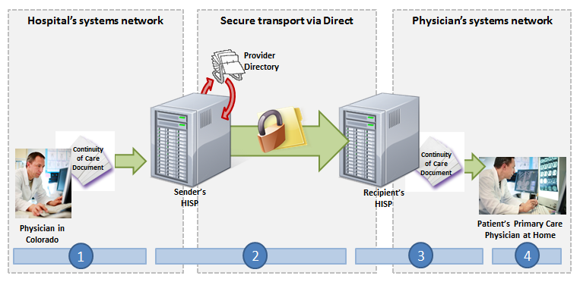
A patient’s primary care physician recommends that all patients over the age of 65 get annual influenza vaccines. As a convenience, the primary care physician’s EHR automatically sends the patient an electronic reminder to make a vaccination appointment. The message is sent via Direct to the patient’s personal health record (PHR) Direct inbox. The PHR’s Direct messaging service then sends a notification email to the patient’s personal email address, indicating that a new message has arrived at her Direct inbox. The patient logs onto her PHR, from which she can retrieve the new Direct message. She reads the reminder, schedules an appointment with her primary care physician to receive the vaccination, and deletes the message.

Meaningful Use Stage 1 Objectives related patient reminders: Send reminders to patients per patient preference for preventive/follow-up care. (Meaningful Use Menu Set Measure 4 for EPs)

Common workflow steps for this scenario
- The primary care physician’s EHR generates an automatic reminder message to the patient. The Direct address provided by the patient is entered as the “recipient” for the message. Prior to sending, the digital certificate associated with the patient’s Direct address is located following the Certificate Discovery for Direct implementation guide.
- When the primary care physician sends the message, it passes through the primary care physician’s Health Information Service Provider (HISP), a contracted brokering agent responsible for the management of security and transport for directed exchange. As it passes through the HISP, the message is encrypted using the x.509 Certificate associated with the patient’s Direct address, and delivered to the patient’s Direct address in accordance with the Applicability Statement for Secure Health Transport.
- The message is received at the patient’s Direct address by the PHR’s HISP. An automated email notification is sent from the patient portal to the patient’s personal, non-Direct email address alerting her of the new secure message that awaits on the PHR Direct inbox.
- When the patient logs into the PHR, she accesses her Direct inbox and views the reminder message.

NwHIN 1.0 specifications and resources recommended for this scenario
Specifications | Resources
Transport and Security  Mechanisms and processes that safely exchange health information over the Internet | - Certificate Discovery using Domain Name System (DNS) and Lightweight Directory Access Protocol (LDAP)  - Applicability Statement for Secure Health Transport  - x.509 for Certificates

