NIST-ONC ehr-Randomizer Application
User Guide for Authorized Developers

TABLE OF CONTENTS
Introduction 3
Overview 5
Pre-Requisite 5
Registration 5
Send request to ONC 5
Accept invitation and set password 5
Complete profile information 7
Manage CEHRTs 8
Add a New CEHRT 8
Declare basic information 9
Define Periods of Availability 10
Days have different time ranges 10
Days have the same time ranges 14
Upload Certificate(s) 15
Modify a CEHRT 16
Delete a CEHRT 16
FAQ: 16
How can I find my username? 16
How do I reset my password? 16
How do I report a problem? 17
How can I delete my account? 17
Document History 18

Introduction
On September 4, 2012, the Department of Health and Human Services (HHS) issued Medicare and Medicaid Programs; Electronic Health Record Incentive Program--Stage 2, Final Rule. This final rule specifies the Stage 2 criteria (meaningful use objectives and measures) that eligible professionals (EPs), eligible hospitals (EHs), and critical access hospitals (CAHs) must meet in order to qualify for Medicare and/or Medicaid electronic health record (EHR) incentive payments. For Meaningful Use Stage 2, the Transition of Care (ToC) objectives and measures, defined at §495.6(j)(14) for EPs and §495.6(l)(11) for EHs/CAHs, require electronic exchange. Specifically, as defined at §495.6(j)(14)(ii)(C) and §495.6(l)(11)(ii)(C), EPs and EHs/CAHs must electronically exchange a summary of care record for at least one transition of care or referral with a recipient that uses a certified EHR technology (CEHRT) created by a different entity than the developer of the CEHRT used by the sending EPs and EHs/CAHs. EPs and EHs/CAHs can satisfy this objective in one of two ways:
- Conduct one or more successful electronic exchanges of a summary of care record with a recipient using technology to receive the summary of care record that was designed by a different EHR developer than the sender’s EHR technology certified at 45 CFR 170.314(b)(2)
- Conduct one or more successful tests with the Centers for Medicare and Medicaid (CMS) designated test EHR during the EHR reporting period
This document describes the test instruction for method 2 in which EPs/EHs/CAHs (“Provider”) conduct an electronic exchange test with a CMS designated test EHR (“Test EHR”) maintained by a participating Developer (“Authorized Developer”) during the EHR reporting period.
To conduct an electronic exchange of a summary of care record with a Test EHR, the Provider must have EHR technology that has been certified to 45 CFR 170.314(b)(2) Transitions of care – create and transmit transition of care/referral summaries (summary of care records). The Authorized Developer’s Test EHR will be certified to 45 CFR 170.314(b)(1) Transitions of care – receive, display, and incorporate transition of care/referral summaries (summary of care records).
Questions or concerns regarding the:
- Cross Vendor Exchange should be directed to ONC at xvendor.exchange@hhs.gov
- ONC HIT Certification Program should be directed to ONC at ONC.Certification@hhs.gov
- ehr-Randomizer test application (“Randomizer”, “application”, “web application”)
- Medicare and Medicaid Programs should be directed to CMS EHR Information Center at 1-888-734-6433* (primary number) or 888-734-6563 (TTY number) Hours of Operation: 7:30 a.m. – 6:30 p.m. (Central Time) Monday through Friday, except federal holidays

Overview
This document provides detailed explanations to Authorized Developers on how to use the NIST-ONC ehr-Randomizer application when participating in the Cross Vendor Exchange.
The workflow for Authorized Developers mainly consists of performing the two following steps:
- Register an account with the application
- Provide information on one or more CEHRT(s) that could be used to perform electronic exchanges

Pre-Requisite
The current version of the Randomizer is not optimized yet for Internet Explorer. Please use an alternate browser such as Firefox, Chrome or Opera.

Registration
An Authorized Developer has to complete three steps to fulfill the registration process:
- Send request to participate in the program to ONC
- Confirm the pre-registration and set a password
- Complete the account profile information

Send request to ONC
The registration process starts by sending a request to Xvendor.exchange@hhs.gov to be included in the program as an Authorized Developer. An email address can be provided in the request: ONC use this address to pre-register the account. Otherwise, the email address from which the request originated is used to send the invitation.
Upon reception of the request, ONC pre-registers the Authorized Developer using the ehr-Randomizer application.

Accept invitation and set password
The randomizer then sends an email to the Authorized Developer that contains a link to the randomizer application. By clicking on the link (or pasting it in the URL bar of your browser of choice), the Authorized Developer is directed on a page as shown in Figure 1 that allows setting up a password for the account.
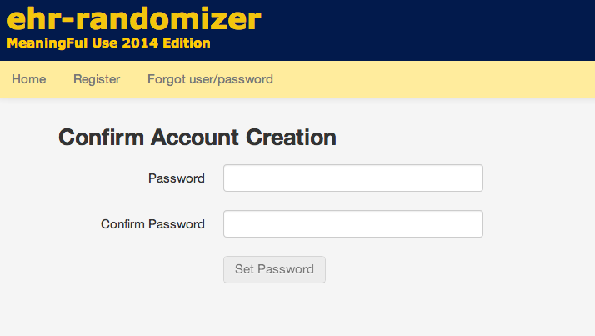
Figure 1 Confirm Account Creation
On this page, the Authorized Developer should enter a password, retype it and validate it by clicking on the “Set Password” button.
If the two passwords match and meet the password policy, a window prompting to accept an agreement (shown in Figure 2) on using the tool is displayed.
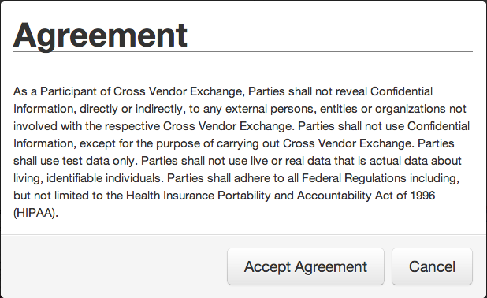
Figure 2 Authorized Developer Agreement
Once the agreement is accepted and the account password is set for the first time, the Authorized Developer should get the following message displayed by the application (Figure 3):
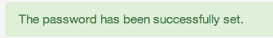
Figure 3 Confirmation Message

Complete profile information
When the password is set, the Authorized Developer can log in for the first time to the application. The login window can be accessed by clicking on the “Login” link located on the right of the navigation bar.
Note: If an Authorized Developer doesn’t remember his username, it can be found in the initial invitation sent out by the tool or in the email that confirms the password has been set.
Once successfully logged-in, the Authorized Developer should provide the missing pieces of information missing in his profile by clicking on the “My account” link located in the navigation bar and filling the form shown in Figure 4.
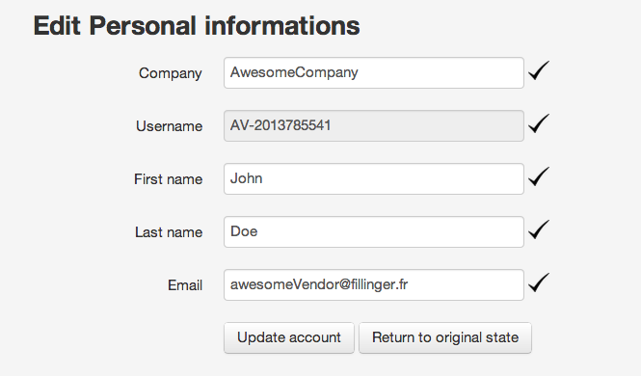
Figure 4 Account Information
The following information should be provided:
- Company name
- First name
- Last name
- Email address
Once all required information is provided, the account information should be saved by clicking on the “Update account” button. After saving changes, the registration process is done.
Note: The username is automatically set and cannot be changed.

Manage CEHRTs
When the account registration has been completed, the next step in using the tool is to register a CEHRT that can be made available for match request.

Add a New CEHRT
In order to define a CEHRT, the Authorized Developer first starts by clicking on the “My CEHRTs” link located in the navigation bar. The first time this page is accessed, the list is empty and the page looks like the one shown in Figure 5.
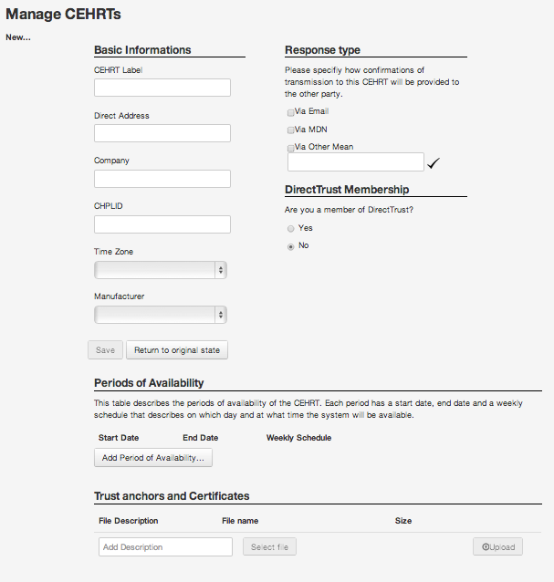
Figure 5 The CEHRT page
When the page is loaded, you can notice that it has 2 main sections:
On the top left is located the list of CEHRTs already declared and a link to add new CEHRTs.
The second section provides the details of a single CEHRT and uses the remaining of the page to provide:
- descriptive information of the CEHRT
- availability of the CEHRT
- trust documents of the CEHRT

Declare basic information
The first step in declaring a CEHRT consists in filling the top part of the form named “Basic Information”, “Response type”, and “DirectTrust Membership”.
For each CEHRT declared within the application, the following pieces of information should be provided:
- CEHRT Label: a label to assign to the CEHRT used to easily recognize a CEHRT
- Direct Address: The address used to communicate with the CEHRT
- Company: The name of the company owning the CEHRT. In most case, this is the same company that registers the account. This field is provided here in order for an Authorized Developer to register a CEHRT owns by another company.
- CHPLID: The CHPLID of the CEHRT
- Time Zone: The time zone in which the CEHRT resides.
- Manufacturer/Technology Developer: The name of organization that developed the CEHRT.
- Response type: Define how the notification of the successful transaction will be performed. It can be either via (multiple choices allowed):
  - Email: The Authorized Developer will send an email to the provider to let him know that the transaction has been successful
  - MDN: The CEHRT will generate a MDN that will be used for notification.
  - Other mean: Any other way that the Authorized Developer sees appropriate to notify the successful completion of an exchange. The Authorized Developer should contact ONC to ensure that the method they use for notifying Providers is acceptable.
- DirectTrust Membership: Whether the CEHRT is an accredited member of DirectTrust and can be found on directtrust.org.
Once this part of the form has been filled, the Authorized Developer should click on the “Save” button located above the section “Periods of Availability”. A message as displayed in Figure 6 will appear to confirm that the CEHRT has been successfully saved.
Figure 6 Message that confirms the CEHRT has been saved
Note: When adding a new CEHRT, it is required to save the basic information before being able to add periods of availability or upload a certificate.

Define Periods of Availability
Once the basic information about a CEHRT has been defined, the next step is to add periods of availability.
A period of availability defines when the system can be reached to perform an electronic exchange of summary of care. Many periods of availability can be defined so an Authorized Developer can have the flexibility to declare precisely when the CEHRT will be available.
Each period of availability has:
- A start date: the weekly schedule is valid after the start date.
- An end date: the weekly schedule is valid before the end date.
- One or more weekly schedule: it is composed of time ranges that can be applied on a specific day (e.g. Monday) or all day of the week.
A time range has a start time and an end time.
The application allows declaring periods of availability that could be expressed like:
“Declare the system available every business day in August between 8am and 5pm, except during lunch time (12pm-1pm) and Wednesdays. Also, the system will be available 24/7 for the first week of September”.
The remainder of the section explains how to enter the periods of availability that are highlighted in the example above.

Days have different time ranges
In order to add a period of availability, click on the button “Add Period of Availability…” shown in Figure 7.
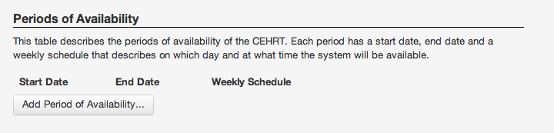
Figure 7 Period of Availability list
The dialog shown in Figure 8 should appear.
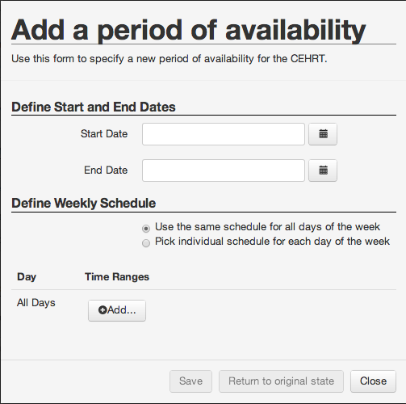
Figure 8 The Period of Availability dialog
First, you need to provide a date for the:
- Start Date field
- End Date field
In our example, we want to have a period of availability that covers the month of August, so we select the first day of August as the “Start Date” and the last day as the “End Date”.
The CEHRT will be available everyday but Wednesdays between 8am-12pm and 1pm-5pm: the schedule is not the same for each day of the week. Click on the radio button “Pick individual schedule for each day of the week”.
The dialog should look like the one in Figure 9.
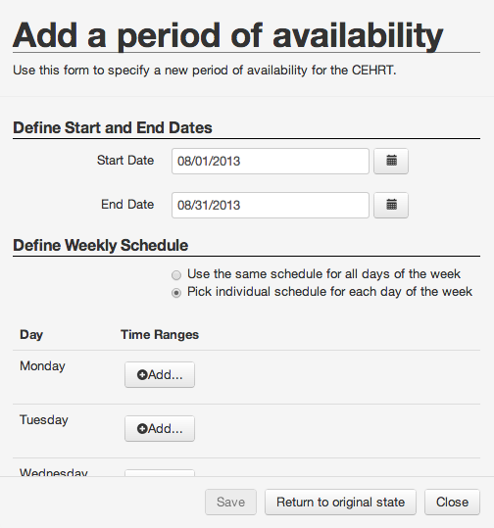
Figure 9 Defining a period of availability
Then, we need to define two periods of availability (8am-12pm and 1pm-5pm) for each business day beside Wednesday.
Click on the button “Add…” located on the right of “Monday”. A new time range appears. Make sure it displays 8:00 to 12:00. Then, click again on “Add…” and define a second time range that shows 13:00 to 17:00.
Repeat that step for “Tuesday”, “Thursday” and “Friday”. The form should look like the one shown in Figure 10.
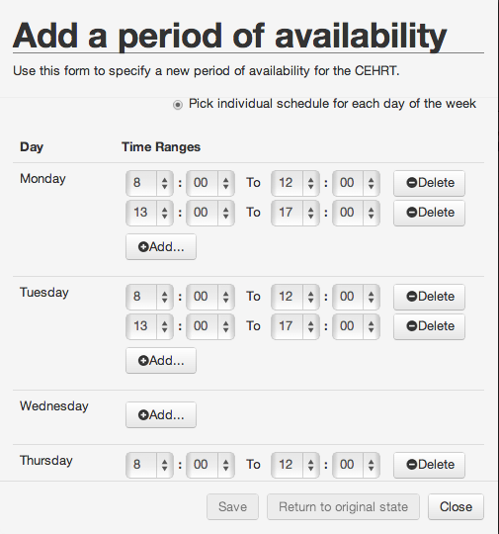
Figure 10 Adding time ranges
Once the form is filled, save the period of availability by clicking on the “Save” button. As a result, the period of availability you defined should now appear in the list as shown in Figure 11.
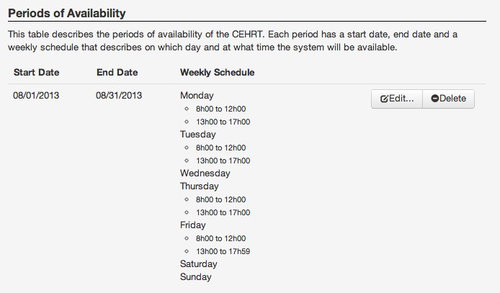
Figure 11 Periods of Availability List

Days have the same time ranges
If every day of the week has the same time ranges, it is possible to define the time ranges once and associate them with every day of the week as shown in Figure 12.
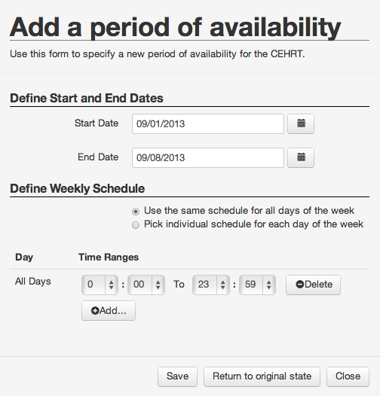
Figure 12
After saving the periods of availability, it appears on the list as shown in Figure 13.
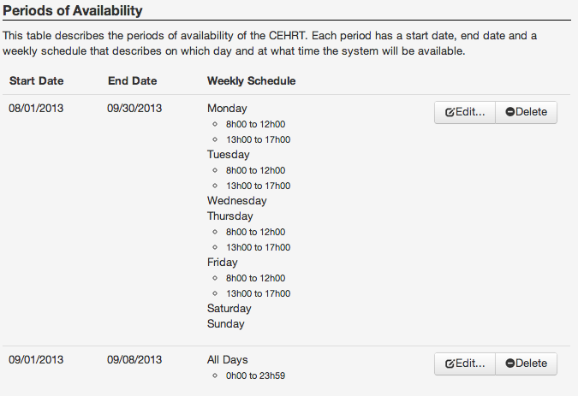
Figure 13

Upload Certificate(s)
The last step to define a CEHRT is to upload the relevant Certificate(s) and/or Trust Anchor(s) that would be required to communicate with this CEHRT. First add a description of the file you are about to upload (Figure 14).
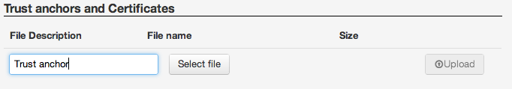
Figure 14 Add File Description
Then select the file you desire to upload (Figure 15).
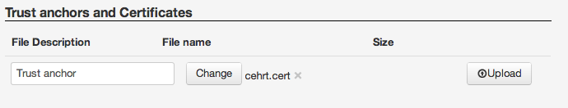
Figure 15 Select the file to upload
Next, select the “Upload” button. If the file is uploaded successfully, a green alert message will appears on top of the page and the list will be updated as shown in Figure 16.
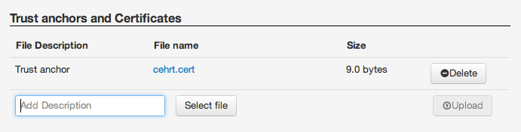
Figure 16 The list after the file has been uploaded

Modify a CEHRT
Any information related to the CEHRT can be edited.
As an Authorized Developer, you should be aware that modifying some aspects of the CEHRT (such as Periods of Availability) after it has been matched against Provider system can result in cancelling matches.

Delete a CEHRT
Deleting a CEHRT from the list is very straightforward. Click on the X located on the right of the CEHRT in the list. Figure 17shows the X icon.
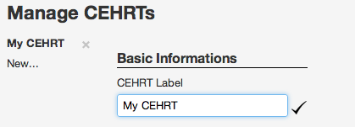
Figure 17 The X button used to delete a CEHRT

FAQ:

How can I find my username?
Your username can be found in the initial invitation you received from the Randomizer tool. It is also in the email that is sent when the pre-registration is confirmed.

How do I reset my password?
If you forgot your password, you can request a new one by clicking on the link “Forgot user/password” located in the navigation bar. On the form, enter your username or the email that was used during the registration process.

How do I report a problem?
In case you are experiencing an issue with the application, you can report it by accessing the form that can be found when clicking on the link “Report a problem” located in the navigation bar.

How can I delete my account?
If you wish to leave the program and delete your account, you can request it on the “My Account” page that can be accessed once you are logged in.

Document History
Version Number | Description of Change | Date
1.0 | Released for use in the Test EHR Program | January 09, 2013
1.1 | - Changed contact information for Medicaid and Medicare Programs from elizabeth.myers@cms.hhs.gov to CMS EHR Information Center at 1-888-734-6433* (primary number) or 888-734-6563 (TTY number) Hours of Operation: 7:30 a.m. – 6:30 p.m. (Central Time) Monday through Friday, except federal holidays  - Changed contact information for ehr-Randomizer test application from NIST at ehr-randomizer@googlegroups.com to ONC  - Grammatical modifications  - Added “accredited” to definition for DirectTrust Membership  - Added document history section to document | February 18, 2015

Health Information Technology: Standards, Implementation Specifications, and Certification Criteria for Electronic Health Record Technology, 2014 Edition; Revisions to the Permanent Certification Program for Health Information Technology, Final Rule

