Meaningful Use Stage 2
Test Instructions for Cross Vendor Exchange

Contents
Introduction 3
Meaningful Use Objectives and Measures 4
Eligible Professionals – §495.6(j)(14) 4
Eligible Hospitals and Critical Access Hospitals – §495.6(l)(11) 5
Referenced Certification Criterion 5
Referenced Standards 6
Test Description 9
Throw and Catch Testing Process 9
Provider Test Instruction 10
Authorized Developer Test Instruction 11
Test Data 11
Test Tool 12
Document History 13

Introduction
On September 4, 2012, the Department of Health and Human Services (HHS) issued Medicare and Medicaid Programs; Electronic Health Record Incentive Program--Stage 2, Final Rule. This final rule specifies the Stage 2 criteria (meaningful use objectives and measures) that eligible professionals (EPs), eligible hospitals (EHs), and critical access hospitals (CAHs) must meet in order to qualify for Medicare and/or Medicaid electronic health record (EHR) incentive payments. For Meaningful Use Stage 2, the Transition of Care (ToC) objectives and measures, defined at §495.6(j)(14) for EPs and §495.6(l)(11) for EHs/CAHs, require electronic exchange. Specifically, as defined at §495.6(j)(14)(ii)(C) and §495.6(l)(11)(ii)(C), EPs and EHs/CAHs must electronically exchange a summary of care record for at least one transition of care or referral with a recipient that uses a certified EHR technology (CEHRT) created by a different entity than the developer of the CEHRT used by the sending EPs and EHs/CAHs. EPs and EHs/CAHs can satisfy this objective in one of two ways:
- Conduct one or more successful electronic exchanges of a summary of care record with a recipient using technology to receive the summary of care record that was designed by a different EHR developer than the sender’s EHR technology certified at 45 CFR 170.314(b)(2)
- Conduct one or more successful tests with the Centers for Medicare and Medicaid (CMS) designated test EHR during the EHR reporting period
This document describes the test instruction for method 2 in which EPs/EHs/CAHs ( “Provider”) conduct an electronic exchange test with a CMS designated test EHR (“Test EHR”) maintained by a participating Developer (“Authorized Developer”) during the EHR reporting period.
To conduct an electronic exchange of a summary of care record with a Test EHR, the Provider must have EHR technology that has been certified to 45 CFR 170.314(b)(2) Transitions of care – create and transmit transition of care/referral summaries (summary of care records). The Authorized Developer’s Test EHR will be certified to 45 CFR 170.314(b)(1) Transitions of care – receive, display, and incorporate transition of care/referral summaries (summary of care records).
Questions or concerns regarding the:
- Cross Vendor Exchange should be directed to ONC at xvendor.exchange@hhs.gov
- ONC HIT Certification Program should be directed to ONC at ONC.Certification@hhs.gov
- Medicare and Medicaid Programs should be directed to CMS at to CMS EHR Information Center at 1-888-734-6433* (primary number) or 888-734-6563 (TTY number) Hours of Operation: 7:30 a.m. – 6:30 p.m. (Central Time) Monday through Friday, except federal holidays
- EHR Randomizer test tool should be directed to ONC

Meaningful Use Objectives and Measures
These meaningful use objectives and measures are from the Medicare and Medicaid Programs; Electronic Health Record Incentive Program--Stage 2, Final Rule issued by the Department of Health and Human Services (HHS) on September 4, 2012. The EP and EH/CAH transition of care or referral objectives and measures are listed below in their entirety; however, this test instruction specifically tests conformance to §495.6(j)(14)(ii)(C)(2) and §495.6(l)(11)(ii)(C)(2), as indicated below. These objectives are included in the Stage 2 core objectives. EPs, EHs, and CAHs must meet the measures associated with core objectives or qualify for an exclusion in order to qualify for an EHR incentive payment.

Eligible Professionals – §495.6(j)(14)
- Objective. The EP who transitions their patient to another setting of care or provider of care or refers their patient to another provider of care provides a summary care record for each transition of care or referral.
- Measures.
- Subject to paragraph (c) of this section, the EP that transitions or refers their patient to another setting of care or provider of care provides a summary of care record for more than 50 percent of transitions of care and referrals;
- Subject to paragraph (c) of this section, the EP that transitions or refers their patient to another setting of care or provider of care provides a summary of care record for more than 10 percent of such transitions and referrals either--
- Electronically transmitted using Certified EHR Technology to a recipient; or
- Where the recipient receives the summary of care record via exchange facilitated by an organization that is a NwHIN Exchange participant or in a manner that is consistent with the governance mechanism ONC establishes for the nationwide health information network, and
- Subject to paragraph (c) of this section an EP must satisfy one of the following:
- Conducts one or more successful electronic exchanges of a summary of care record meeting the measure specified in paragraph (j)(14)(ii)(B) of this section with a recipient using technology to receive the summary of care record that was designed by a different EHR developer than the sender's EHR technology certified at 45 CFR 170.314(b)(2); or
- Conducts one or more successful tests with the CMS designated test EHR during the EHR reporting period.
- Exclusion in accordance with paragraph (h)(2) of this section. Any EP who transfers a patient to another setting or refers a patient to another provider less than 100 times during the EHR reporting period.

Eligible Hospitals and Critical Access Hospitals – §495.6(l)(11)
- Objective. The eligible hospital or CAH that transitions their patient to another setting of care or provider of care or refers their patient to another provider of care provides a summary care record for each transition of care or referral.
- Measures.
- Subject to paragraph (c) of this section, the eligible hospital or CAH that transitions or refers their patient to another setting of care or provider of care provides a summary of care record for more than 50 percent of transitions of care and referrals;
- Subject to paragraph (c) of this section, the eligible hospital or CAH that transitions or refers their patient to another setting of care or provider of care provides a summary of care record for more than 10 percent of such transitions and referrals either--
- Electronically transmitted using Certified EHR Technology to a recipient; or
- Where the recipient receives the summary of care record via exchange facilitated by an organization that is a NwHIN Exchange participant or in a manner that is consistent with the governance mechanism ONC establishes for the nationwide health information network, and
- Subject to paragraph (c) of this section an eligible hospital or CAH must satisfy one of the following:
- Conducts one or more successful electronic exchanges of a summary of care record meeting the measure specified in paragraph (j)(14)(ii)(B) of this section with a recipient using technology to receive the summary of care record that was designed by a different EHR developer than the sender's EHR technology certified at 45 CFR 170.314(b)(2); or
- Conducts one or more successful tests with the CMS designated test EHR during the EHR reporting period.

Referenced Certification Criterion
This certification criterion is from the Health Information Technology: Standards, Implementation Specifications, and Certification Criteria for Electronic Health Record Technology, 2014 Edition; Revisions to the Permanent Certification Program for Health Information Technology, Final Rule issued by the Department of Health and Human Services (HHS) on September 4, 2012.
§170.314(b)(2) Transitions of care – create and transmit of care/referral summaries
- Create. Enable a user to electronically create a transition of care/referral summary formatted according to the standard adopted at §170.205(a)(3) that includes, at a minimum, the Common MU Data Set and the following data expressed, where applicable, according to the specified standard(s):
- Encounter diagnoses. The standard specified in § 170.207(i) or, at a minimum, the version of the standard specified §170.207(a)(3);
- Immunizations. The standard specified in §170.207(e)(2);
- Cognitive status;
- Functional status; and
- Ambulatory setting only. The reason for referral; and referring or transitioning provider’s name and office contact information.
- Inpatient setting only. Discharge instructions.
- Transmit. Enable a user to electronically transmit the transition of care/referral summary created in paragraph (b)(2)(i) of this section in accordance with:
- The standard specified in §170.202(a).
- Optional. The standards specified in §170.202(a) and (b).
- Optional. The standards specified in §170.202(b) and (c).
For more information on the Test Procedure for §170.314 (b)(2) Transitions of care – create and transmit summary care records, reference (navigation: 2014 Edition Test Method).

Referenced Standards
The standards listed below are referenced in §170.314(b)(2) Transitions of care – create and transmit of care/referral summaries.
The Secretary adopts the following transport standards:
§170.202 Transport standards. | Regulatory Referenced Standard
- Standard. ONC Applicability Statement for Secure Health Transport (incorporated by reference in §170.299).
- Standard. ONC XDR and XDM for Direct Messaging Specification (incorporated by reference in §170.299).
- Standard. ONC Transport and Security Specification (incorporated by reference in §170.299).

The Secretary adopts the following content exchange standards
and associated implementation specifications:
§170.205 Content exchange standards and implementation specifications for exchanging electronic health information. | Regulatory Referenced Standard
- Standard. HL7 Implementation Guide for CDA® Release 2: IHE Health Story Consolidation, (incorporated by reference in § 170.299). The use of the “unstructured document” document-level template is prohibited.

The Secretary adopts the following code sets, terminology,
and nomenclature as the vocabulary standards for the
purpose of representing electronic health information:
§170.207 Vocabulary standards for representing electronic health information | Regulatory Referenced Standard
- Standard. IHTSDO SNOMED CT® International Release July 2012 (incorporated by reference in §170.299) and US Extension to SNOMED CT® March 2012 Release (incorporated by reference in §170.299).
(b)(2) Standard. The code set specified at 45 CFR 162.1002(a)(5). | 45 CFR 162.1002 Medical data code sets  The Secretary adopts the following code set maintaining organization’s code sets as the standard medical data code sets:  (a) International Classification of Diseases, 9th Edition, Clinical Modification, (ICD-9- CM), Volumes 1 and 2 (including The Official ICD-9-CM Guidelines for Coding and Reporting), as maintained and distributed by HHS, for the following conditions:  (5) The combination of Health Care Financing Administration Common Procedure Coding System (HCPCS), as maintained and distributed by HHS, and Current Procedural Terminology, Fourth Edition (CPT–4), as maintained and distributed by the American Medical Association, for physician services and other health care services. These services include, but are not limited to, the following:
(b)(3) Standard. The code set specified at 45 CFR 162.1002(a)(4). | 45 CFR 162.1002 Medical data code sets  The Secretary adopts the following code set maintaining organization’s code sets as the standard medical data code sets:  (a) International Classification of Diseases, 9th Edition, Clinical Modification, (ICD-9- CM), Volumes 1 and 2 (including The Official ICD-9-CM Guidelines for Coding and Reporting), as maintained and distributed by HHS, for the following conditions:  (4) Code on Dental Procedures and Nomenclature, as maintained and distributed by the American Dental Association, for dental services.
(b)(4) Standard. The code set specified at 45 CFR 162.1002(c)(2) for the indicated procedures or other actions taken. | 45 CFR 162.1002 Medical data code sets  The Secretary adopts the following code set maintaining organization’s code sets as the standard medical data code sets:  (c)(3) International Classification of Diseases, 10th Revision, Procedure Coding System (ICD–10–PCS) (including The Official ICD–10–PCS Guidelines for Coding and Reporting), as maintained and distributed by HHS, for the following procedures or other actions taken for diseases, injuries, and impairments on hospital inpatients reported by hospitals:  - Prevention.  - Diagnosis.  - Treatment.  - Management.
(c) Laboratory Tests
(2) Standard. Logical Observation Identifiers Names and Codes (LOINC®) Database version 2.40, a universal code system for identifying laboratory and clinical observations produced by the Regenstrief Institute, Inc. (incorporated by reference in § 170.299).
(d) Medications
(2) Standard. RxNorm, a standardized nomenclature for clinical drugs produced by the United States National Library of Medicine, August 6, 2012 Release (incorporated by reference in § 170.299).
(e) Immunizations
(2) Standard. HL7 Standard Code Set CVX -- Vaccines Administered, updates through July 11, 2012 (incorporated by reference in § 170.299).
(f) Race and Ethnicity. Standard. The Office of Management and Budget Standards for Maintaining, Collecting, and Presenting Federal Data on Race and Ethnicity, Statistical Policy Directive No. 15, as revised, October 30, 1997 (see “Revisions to the Standards for the Classification of Federal Data on Race and Ethnicity,” available at http://www.whitehouse.gov/omb/fedreg_1997standards)
(f) Preferred language. Standard. As specified by the Library of Congress, ISO 639-2 alpha-3 codes limited to those that also have a corresponding alpha-2 code in ISO 639-1. (incorporated by reference in § 170.299).
(h) Smoking status. Standard. Smoking status must be coded in one of the following SNOMED CT® codes:
  - Current every day smoker. 449868002
  - Current some day smoker. 428041000124106
  - Former smoker. 8517006
  - Never smoker. 266919005
  - Smoker, current status unknown. 77176002
  - Unknown if ever smoked. 266927001
  - Heavy tobacco smoker. 428071000124103
  - Light tobacco smoker. 428061000124105
(i) Encounter diagnoses. Standard. The code set specified at 45 CFR 162.1002(c)(2) for the indicated conditions. | 45 CFR 162.1002 Medical data code sets.  The Secretary adopts the following  maintaining organization’s code sets as  the standard medical data code sets:  (c)(2) International Classification of  Diseases, 10th Revision, Clinical Modification  (ICD–10–CM) (including The Official  ICD–10–CM Guidelines for Coding  and Reporting), as maintained and distributed  by HHS, for the following conditions:  - Diseases.  - Injuries.  - Impairments.  - Other health problems and their manifestations.  - Causes of injury, disease, impairment, or other health problems.

Test Description
This test evaluates the capability for CEHRT to conduct one or more successful electronic exchange tests with the CMS designated Test EHR. The testing process will approximate a “real-life” environment as much as possible. Electronic exchange will be accomplished by utilizing the required transport standard (§170.202(a) Direct Messaging), not the optional transport standards (§170.202(b) XDR/XDM or §170.202(c) SOAP). Lastly, the structure and content of the message will not be validated.
The Provider supplies the test data for this test.

Throw and Catch Testing Process
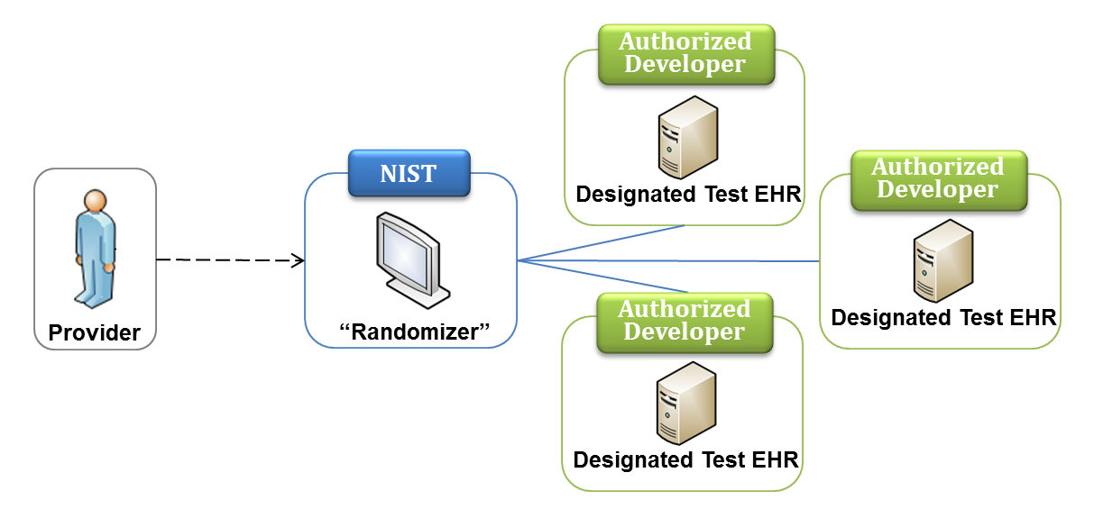
Figure 1: Throw and Catch Testing Process
The test instruction utilizes the “Throw and Catch” testing process (as shown in Figure 1) developed by ONC, CMS, and NIST. The “Throw and Catch” method consists of multiple designated CEHRTs as potential Test EHRs, installed and running at the respective Authorized Developer sites, and a software system, called “Randomizer”, developed and run by NIST. The Provider enters their CEHRT information into the “Randomizer” which uses this information to randomly select a “Test EHR” that was created by a different developer than the Provider’s CHERT and is listed as an available Test EHR. Utilizing the information provided by the “Randomizer”, the Provider can send content to the selected Test EHR and complete the entire testing process, as shown in Figure 2.
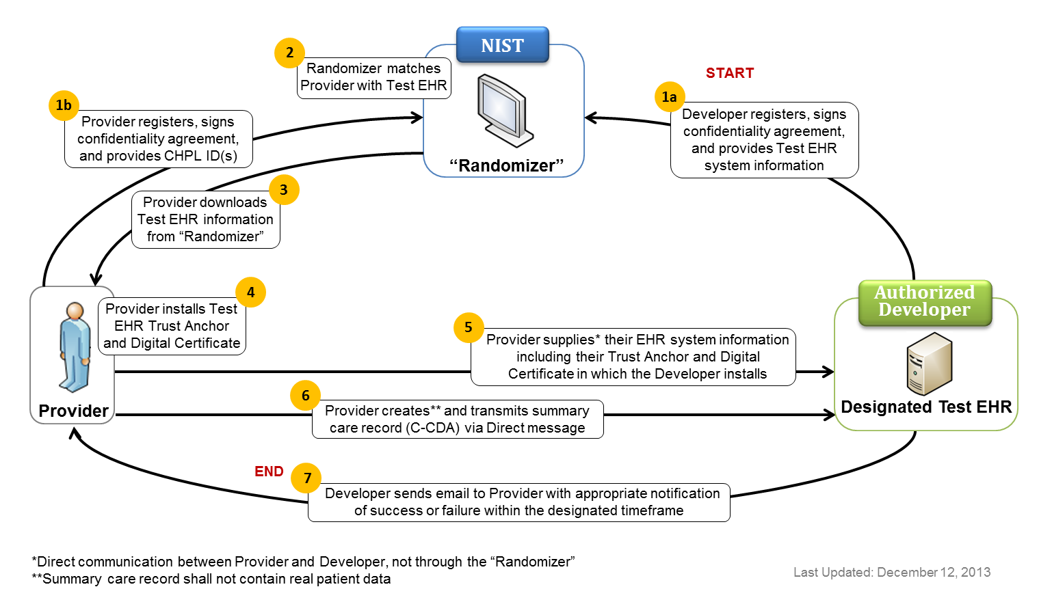
Figure 2: Testing Process Workflow

Provider Test Instruction
This Provider test instruction is organized into eight sections:
- Register – Provider registers to the “Randomizer”, enters contact information, and provides for CEHRT product name(s) and developer(s) for Complete or Modular EHR technology certified to §170.314(b)(2) that will be used by the “Randomizer” to match the Provider EHR to a Test EHR system created by a different developer
- Sign Confidentiality Agreement – Provider utilizes “Randomizer” to sign a confidentiality agreement
- Receive Test EHR Information – Provider downloads the following Test EHR information from the “Randomizer”:
  - Direct Address
  - Trust Anchor
  - Authorized Developer Contact Information
- Install Test EHR Trust Anchor and Digital Certificate – Provider utilizes information from the “Randomizer” to install the Test EHR’s Trust Anchor and Digital Certificate
- Schedule and Set Up Test with Authorized Developer – Provider utilizes information from the “Randomizer” to schedule a testing time with Authorized Developer, and supplies the Provider’s EHR Trust Anchor and Digital Certificate (communications conducted directly between the Provider and Developer, not through the “Randomizer”)
- Create Summary Care Record – Using test data only (that is, no real, live patient data), Provider creates a Consolidated CDA conformant summary care record
- Transmit Direct Message – Provider sends a Direct Message with the Consolidated CDA conformant summary care record to Test EHR
- Receive Email Notification – Provider waits to receive an email notification from the Authorized Developer indicating if a message was successfully received by the Test EHR or if the test was a failure within one day of the completion of the test. If successful, the notification can be used for Meaningful Use attestation of §495.6(j)(14)(ii)(C) and/or §495.6(l)(11)(ii)(C)

Authorized Developer Test Instruction
This Authorized Developer test instruction is organized into eight sections:
- Register – Authorized Developer registers to the “Randomizer”, enters contact information, and provides Test EHR system information including:
  - Product Name(s), Version Number(s) and Product Type for Complete or Modular EHR technology certified to §170.314(b)(1) that will be used by the “Randomizer” to ensure that the Provider EHR is matched to a different Test EHR system
  - Direst Address
  - Trust Anchor
  - System availability and additional information that can be used by Provider to schedule a test
- Sign Confidentiality Agreement – Authorized Developer utilizes the “Randomizer” to sign a confidentiality agreement
- Receive Provider EHR Information – Authorized Developer is contacted directly by Provider who supplies the following information about the Provider EHR:
  - Direct Address
  - Trust Anchor
  - Provider Contact Information
- Install Provider EHR Trust Anchor and Digital Certificate – Utilizing information supplied by Provider, Authorized Developer installs the Provider EHR’s Trust Anchor and Digital Certificate
- Schedule and Set Up Test with Provider – Authorized Developer schedules a testing time with Provider. Testing shall begin within five days (of scheduled availability) of establishing mutual trust
- Receive Summary Care Record – Authorized Developer receives Consolidated CDA conformant summary care record via Direct Message from Provider
- Create and Send Email Notification – Authorized Developer creates and sends an email notification to the Provider indicating if the Provider’s Direct Message was successfully received by the Test EHR or if the test was a failure within one day of the completion of the test

Test Data
The Provider supplies the data for this test.
As a Participant of Cross Vendor Exchange, Parties shall not reveal Confidential Information, directly or indirectly, to any external persons, entities or organizations not involved with the respective Cross Vendor Exchange. Parties shall not use Confidential Information, except for the purpose of carrying out Cross Vendor Exchange. Parties shall use test data only. Parties shall not use live or real data that is actual data about living, identifiable individuals. Parties shall adhere to all Federal Regulations including, but not limited to the Health Insurance Portability and Accountability Act of 1996 (HIPAA).

Test Tool
The following tool is available to match a Provider with a certified EHR technology (Designated Test EHR):
- NIST Randomizer Tool – a NIST tool designed specifically to support this test. The tool is available as a Web Application
- The web application service is available at: http://ehr-randomizer.nist.gov
Support for this tool is available by submitting questions to ONC
Multiple browsers may be used to access this tool; if the tool does not load completely using Internet Explorer 8 or Internet Explorer 9, alternative browsers such as Firefox, Google Chrome, or Safari are recommended. The Randomizer Tool uses non-standard ports. If your firewall blocks HTTP traffic on non-standard ports, this tool may not be accessible. Please retry access from a location without a firewall that blocks non-standard ports.

Document History
Version Number | Description of Change | Date
Draft 11 | Released for use in the Test EHR Program | March 20, 2013
2 | - Changed contact information for Medicaid and Medicare Programs from elizabeth.myers@cms.hhs.gov to CMS EHR Information Center at 1-888-734-6433* (primary number) or 888-734-6563 (TTY number) Hours of Operation: 7:30 a.m. – 6:30 p.m. (Central Time) Monday through Friday, except federal holidays  - Changed contact information for ehr-Randomizer test application from NIST at ehr-randomizer@googlegroups.com to ONC  - Deleted “Inquiries may be sent to Inquiries may also be sent to this user group via email: ehr-randomizer@googlegroups.com.”  - Added cover page and document history section to document | February 18, 2015

Health Information Technology: Standards, Implementation Specifications, and Certification Criteria for Electronic Health Record Technology, 2014 Edition; Revisions to the Permanent Certification Program for Health Information Technology, Final Rule

