2016_SRNT_Letterhead_B.pdf

October 1, 2018

To Whom It May Concern:

On behalf of the Society for Research on Nicotine & Tobacco (SRNT), I want to thank you for this opportunity to comment on the classifications for smoking status documentation in the EHR through the office of the National Coordinator for Health Information Technology.

SRNT believes the current choices for documenting smoking status in most EHRs are overlapping and duplicative, frequently resulting in confusion at the point of care. This has been a source of frustration for many clinicians and health systems.

It is critical for the science and understanding of who is using combustible cigarettes that there be a consistent, clear, non-redundant categorization in EHR. Specifically, SRNT asks that you:

* Simplify and reduce the number of smoking status choices/classifications;
* Remove overlapping smoking status classifications; and
* Include clear, non-duplicative smoking status classification status.

Thank you for your consideration of this request.

Sincerely,

Bruce Wheeler

Executive Director

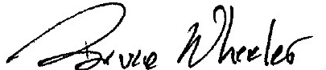

Bruce Wheeler

Executive Director