On the left-hand side-bar > Click Pregnancy Status:
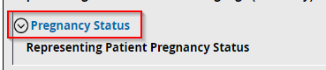

The link is for Representing Health Care Data for Emergency Medical Services:
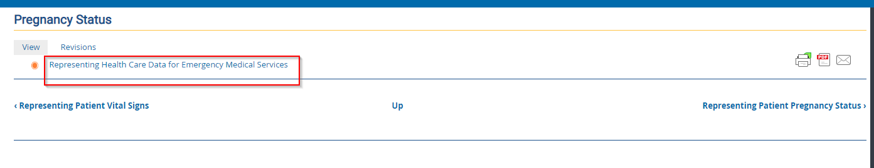
But it should be Representing Patient Pregnancy Status

